AWS Transit Gateway - CFT Deployment

Justin Harris

CE, EMEA

# Introduction

This guide will walk the reader through a deployment of an AWS Transit Gateway (TGW) with two spoke VPCs and a Security VPC using a cloud formation template. The Security VPC will contain 2 Palo Alto Networks VM-Series firewalls configured to enable outbound and Intra-VPC inspection.

AWS Transit Gateway is a service that enables customers to connect their Amazon Virtual Private Clouds (VPCs) and their on-premises networks to a single gateway. As you grow the number of workloads running on AWS, you need to be able to scale your networks across multiple accounts and Amazon VPCs to keep up with the growth. Today, you can connect pairs of Amazon VPCs using peering. However, managing point-to-point connectivity across many Amazon VPCs, without the ability to centrally manage the connectivity policies, can be operationally costly and cumbersome. For on-premises connectivity, you need to attach your AWS VPN to each individual Amazon VPC. This solution can be time consuming to build and hard to manage when the number of VPCs grows into the hundreds.

With AWS Transit Gateway, you only have to create and manage a single connection from the central gateway in to each Amazon VPC, on-premises data center, or remote office across your network. Transit Gateway acts as a hub that controls how traffic is routed among all the connected networks which act like spokes. This hub and spoke model significantly simplifies management and reduces operational costs because each network only has to connect to the Transit Gateway and not to every other network. Any new VPC is simply connected to the Transit Gateway and is then automatically available to every other network that is connected to the Transit Gateway. This ease of connectivity makes it easy to scale your network as you grow.

# Expected Outcome

This guide will walk the read through the following configurations.

* Building 3 VPCs. 2 Spokes and 1 Security
* Build a Transit Gateway with 2 route tables
* Perform the necessary Transit Gateway Attachments and Associations.
* Update the TGW Route Tables accordingly.
* Deploy 2 VM-Series firewalls manual with proper routing, Security and NAT Policies.
* Update the VPC Route Tables accordingly.
* Deploy a testing client and testing web server.

# 

# Prerequisites

## Before You Begin

This guide assumes prior knowledge of and access to the AWS console. The guide also assumes prior knowledge of the Palo Alto Networks VM-Series firewall.

The reader should now login into the AWS console and access their desired region.

# VPCs

## Overview

The guide will walk through the creating of 3 VPCs. The 2 spokes VPCs will each have 1 private subnet. It is suggested for demonstration purposes to place the subnets for each spoke in differing Availability Zones. This will show the outbound traffic traversing firewalls in the local AZ.

The Security VPC will have 8 total subnets spread across 2 Availability Zones. Each Availability Zone containing a subnet for Management, Untrust, Trust interfaces of the firewall and a subnet dedicated to the AWS TGW attachment as per AWS's recommendation.

## Process Flow

* 1. VPC Creations
     1. In the AWS console, open the VPC Service.
     2. Select Your VPCs in the left-hand menu and hit the Create VPC button.
     3. Specify a Name and CIDR for your spoke VPC. 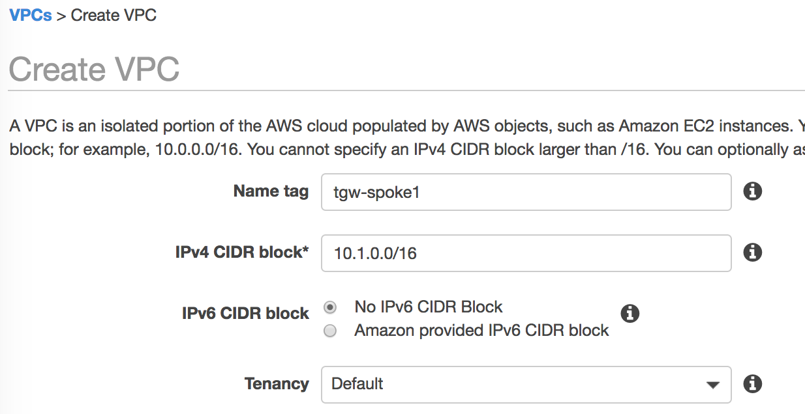
     4. Select the Create Button and Close on the next page to return to the VPC list.
     5. Repeat the process to create a second spoke and the Security VPCs. 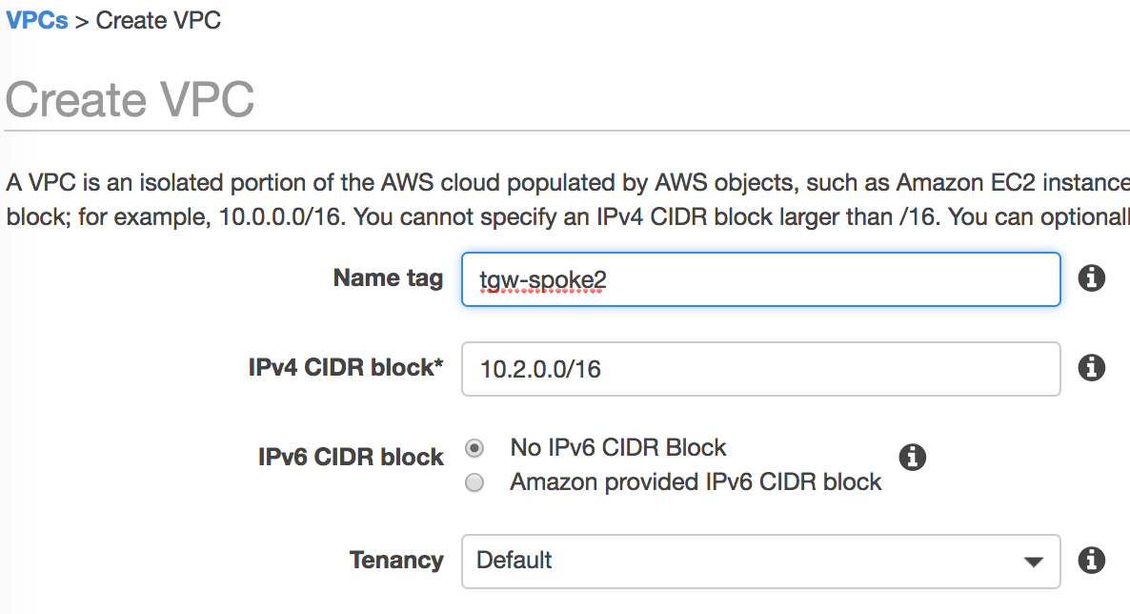 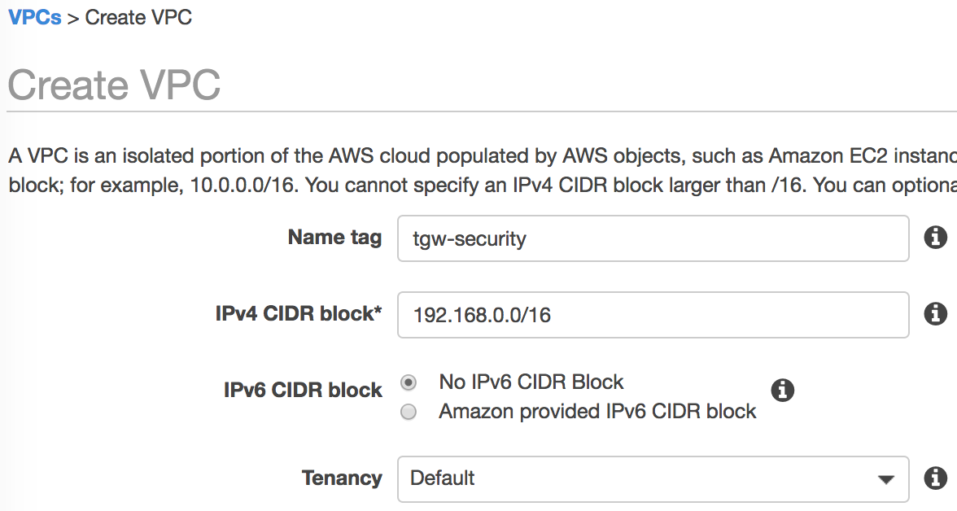

# Subnets

## Overview

The guide moves on to creating subnets in each of the VPCs. In order to demonstrate cross zone functionality, it is suggested to create the spokes subnets in different zones and security subnets in each of those zones. E.g.

* Spoke 1 - 1 subnet in us-west-2a
* Spoke 2 - 1 subnet in us-west-2b
* Security - 4 subnets each in both us-west-2a and us-west-2b

## Process Flow

* 1. Spoke Subnet Creations
     1. In the AWS console, open the VPC Service.
     2. Select Subnets in the left-hand menu and select the Create Subnet button.
     3. Specify a name, the Spoke VPC, AZ and CIDR block.

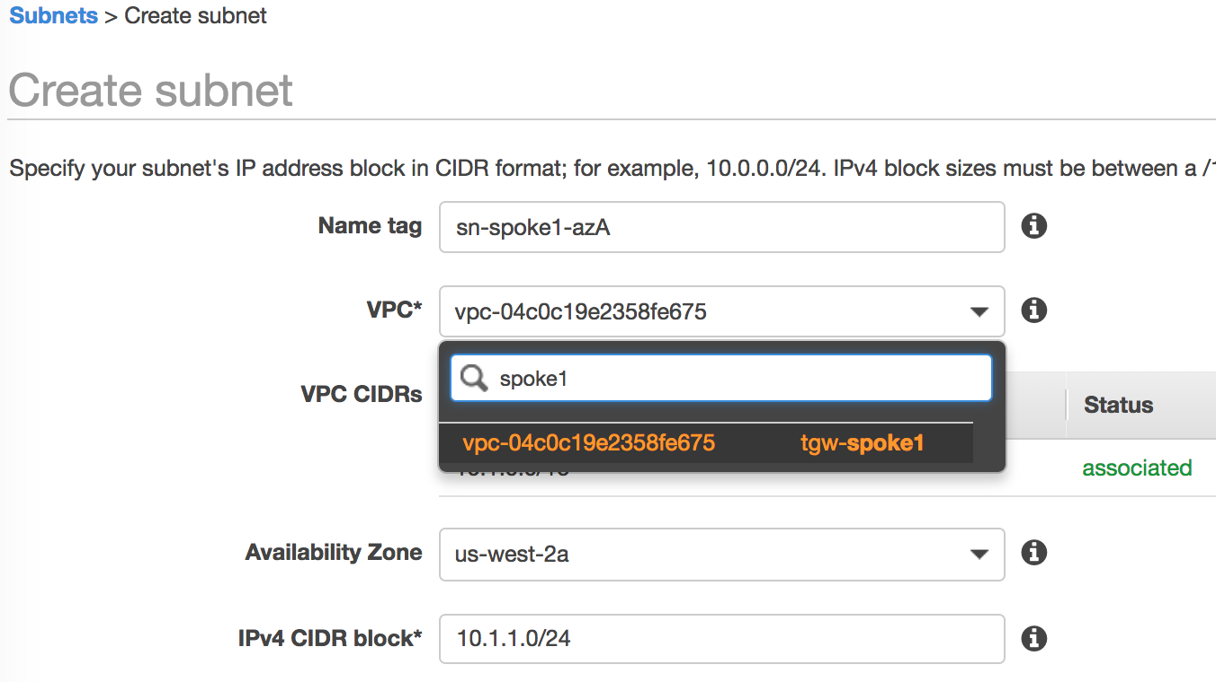

* + 1. Select the Create Button and Close to return to the subnets list.
    2. Repeat the Process for Spoke 2. 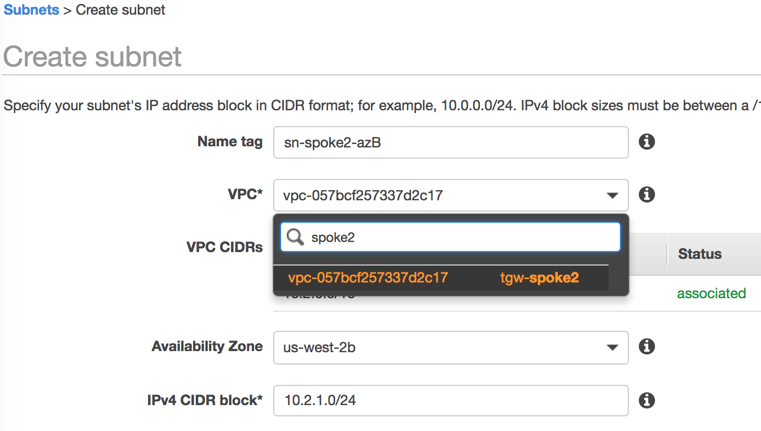
  1. Create Security Subnets

The Security VPC contains the following subnets. The guide will walk through the first subnet creation. It is up to the reader to create the remaining 7.

Availability Zone A

* MgmtA - 192.168.1.0/24
* UntrustA - 192.168.11.0/24
* TrustA - 192.168.21.0/24
* TGWattachA - 192.168.31.0/24

Availability Zone B

* MgmtB - 192.168.2.0/24
* UntrustB - 192.168.12.0/24
* TrustB - 192.168.22.0/24
* TGWattachB - 192.168.32.0/24
  + 1. In the AWS console, open the VPC Service.
    2. Select Subnets in the left-hand menu and select the Create Subnet button.
    3. Specify a name, the Security VPC, AZ and CIDR block. 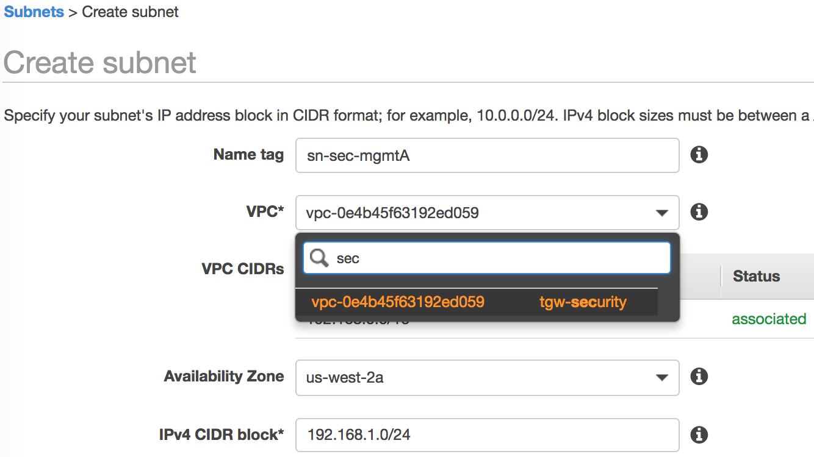
    4. Select the Create Button and Close to return to the Subnets list.
    5. Repeat the process for the remaining subnets.

After Completion, the reader should have 10 subnets in total.

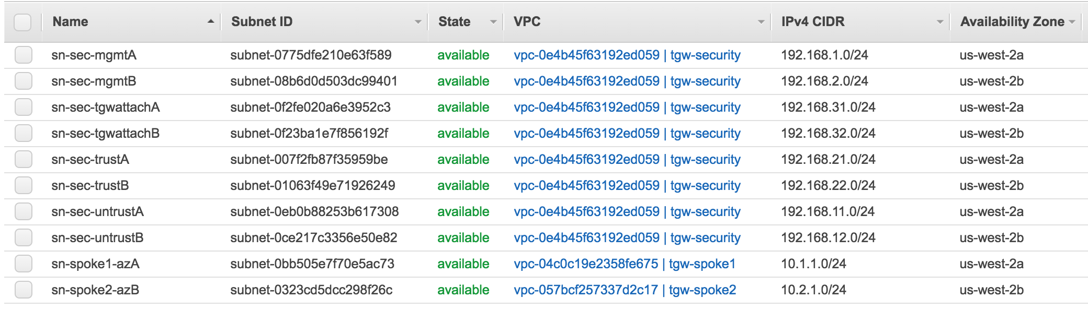

# Transit Gateway

## Overview

At this stage, the Transit Gateway is created along with the attachments. Once the TGW is created, the reader will then be able to create the VPC route tables with routes to the TGW.

## Process Flow

* 1. Transit Gateway Creation
     1. In the AWS console, open the VPC Service.
     2. Select Transit Gateways in the left-hand menu and select the Create Transit Gateway button.
     3. Specify a Name and optionally a description. While not required, the reader may wish to disable "Default route table association" and "Default route table propagation". This will prevent undesired association into the security route table. 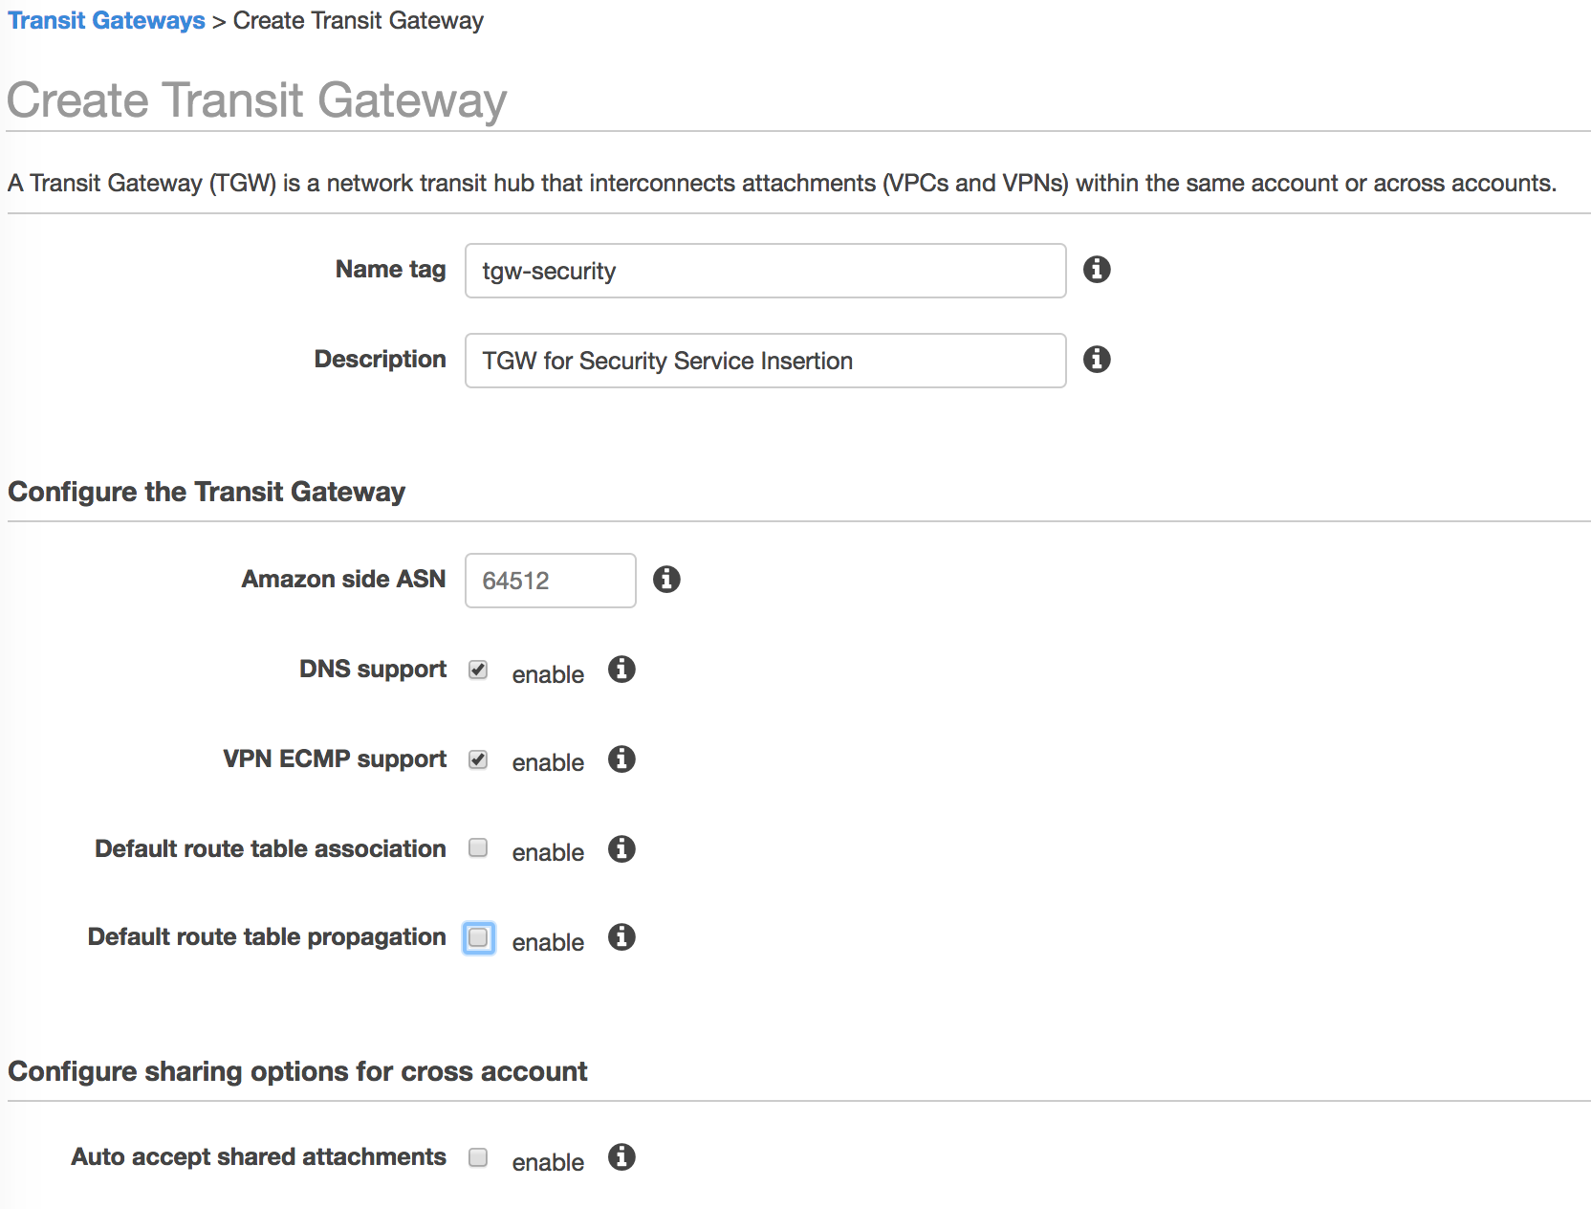
     4. Select the Create Button and Close to return to the Transit Gateways list.
     5. Wait for the TGW to move out of Pending and into the Active state before moving on.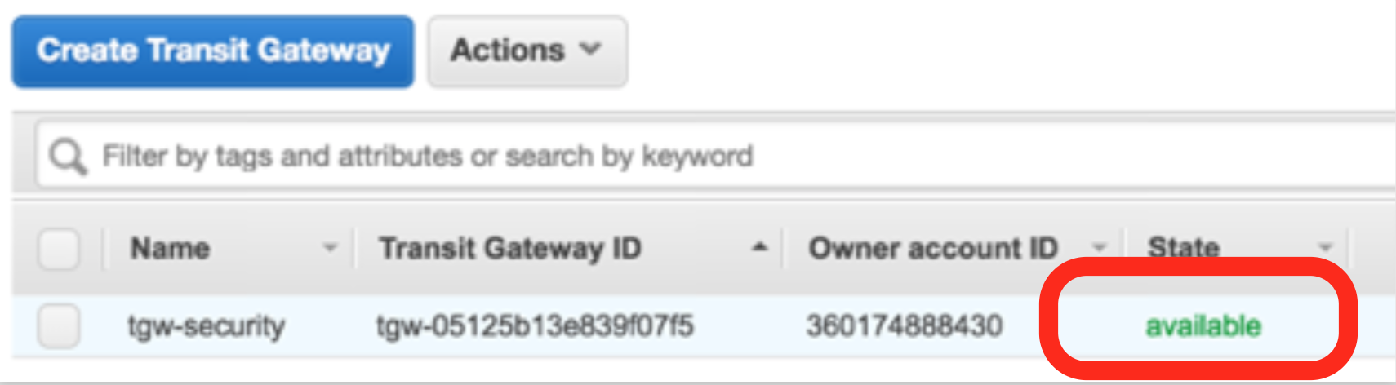
  2. Transit Gateway Route Tables
     1. In the AWS console, open the VPC Service.
     2. Select Transit Gateway Route Tables in the left-hand menu and select the Create Transit Gateway Route Table button.
     3. Specify a Name and the TGW ID. 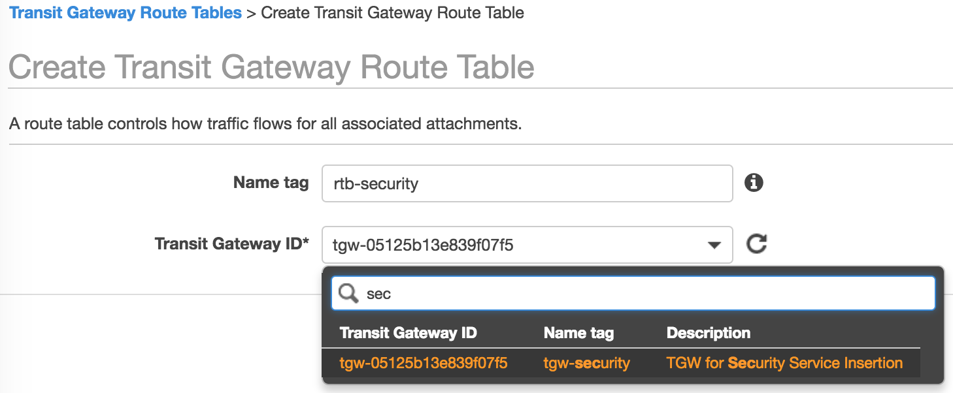
     4. Select the Create button and the close button to return to Route Table List.
     5. Repeat the process for the Spoke Route table. 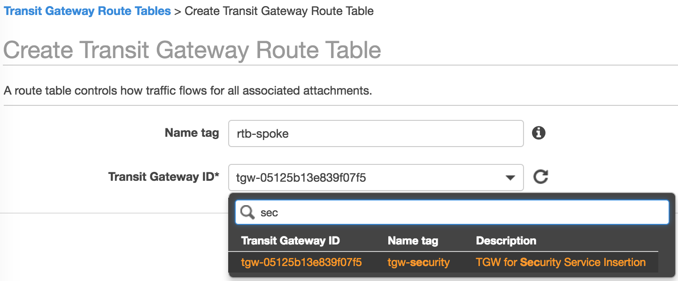
  3. Transit Gateway Attachments
     1. In the AWS console, open the VPC Service.
     2. Select Transit Gateway Attachments in the left-hand menu and select the Create Transit Gateway Attachment button.
     3. Select the Transit Gateway ID and Attachment Type VPC.
     4. Provide a Name and specify the Security VPC ID.
     5. Specify the Attachment Subnets previously created in each zone.
* The Subnet IDs will not be visible until after the VPC is selected.

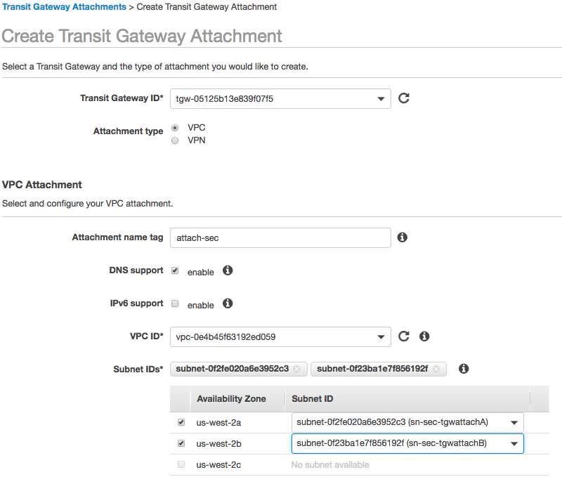

* + 1. Select the Create Button and Close on the following screen.
    2. Repeat the process for the Spoke VPCs. 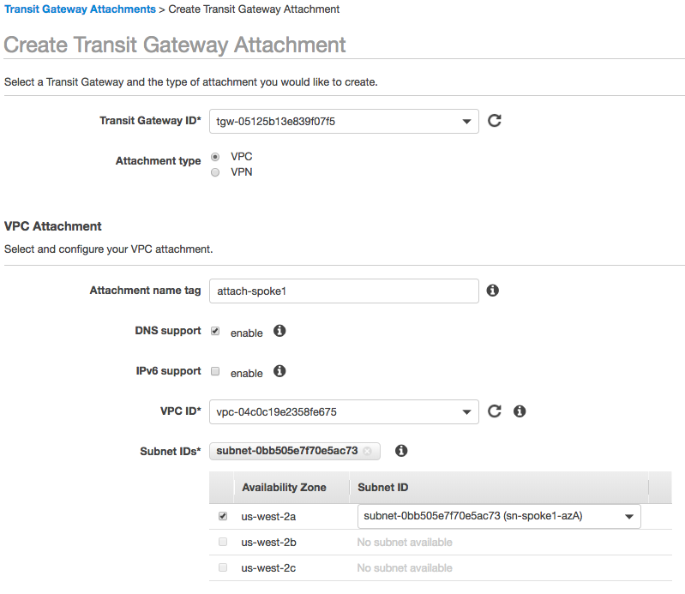 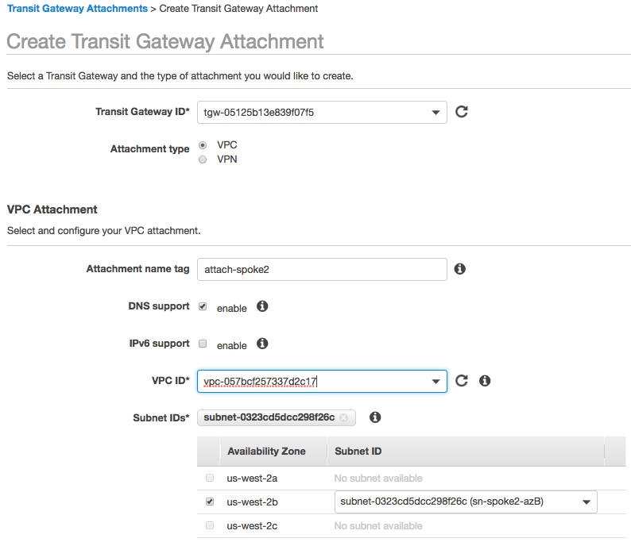
  1. Transit Gateway Associations
     1. In the AWS console, open the VPC Service.
     2. Select Transit Gateway Route Tables in the left-hand menu and select the Spoke Route Table.
     3. In the bottom pane, select the Associations Tab and Select the Create Association Button. 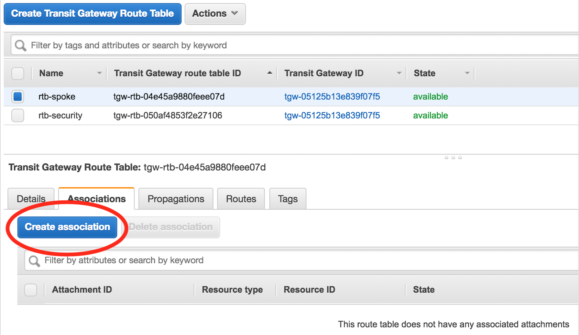
     4. Select the Spoke VPC 1 from the Choose Attachment drop down. 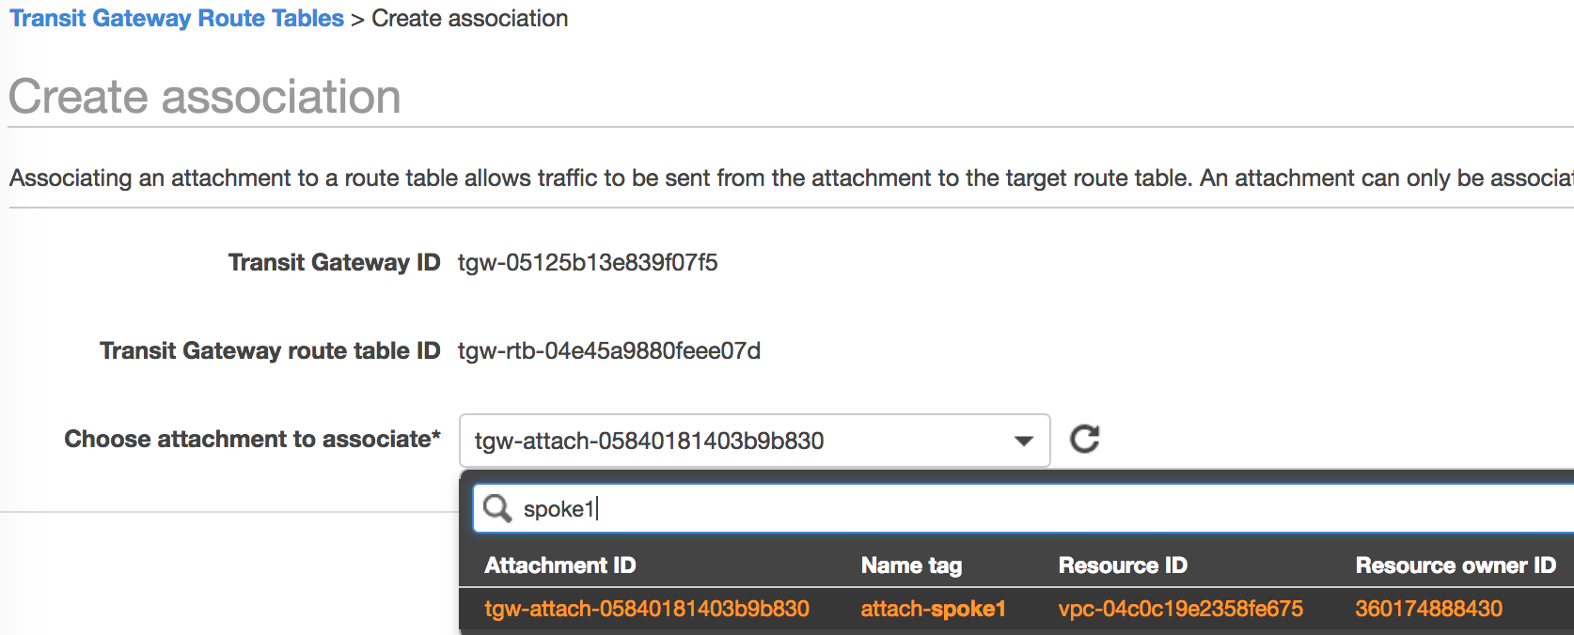
     5. Select the Create Button and then Close.
     6. Repeat the process for Spoke 2.
     7. Wait for both Associations to be "associated" before proceeding. 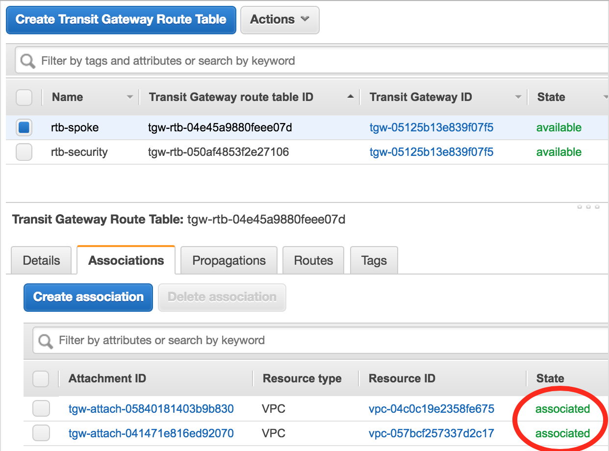
     8. Move to Propagations Tab and select the Create Propagation button.
     9. Select the Security VPC in the drop down.
* The reader should note that the Security VPC is propagated to the Spoke route table and in the subsequent steps the opposite will be performed.

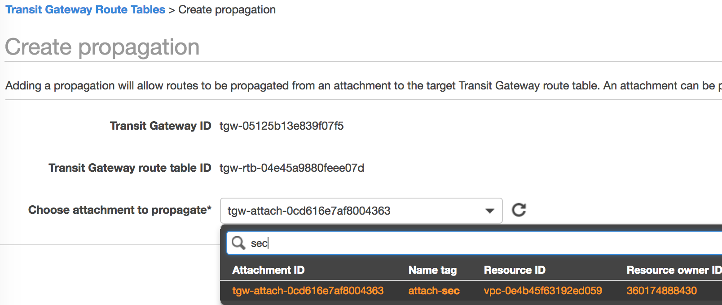

* + 1. Select the Create Propagation button and close on the next screen.
    2. Once Complete, select the Routes Tab in the bottom pane to verify that the Security VPC route has been propagated. 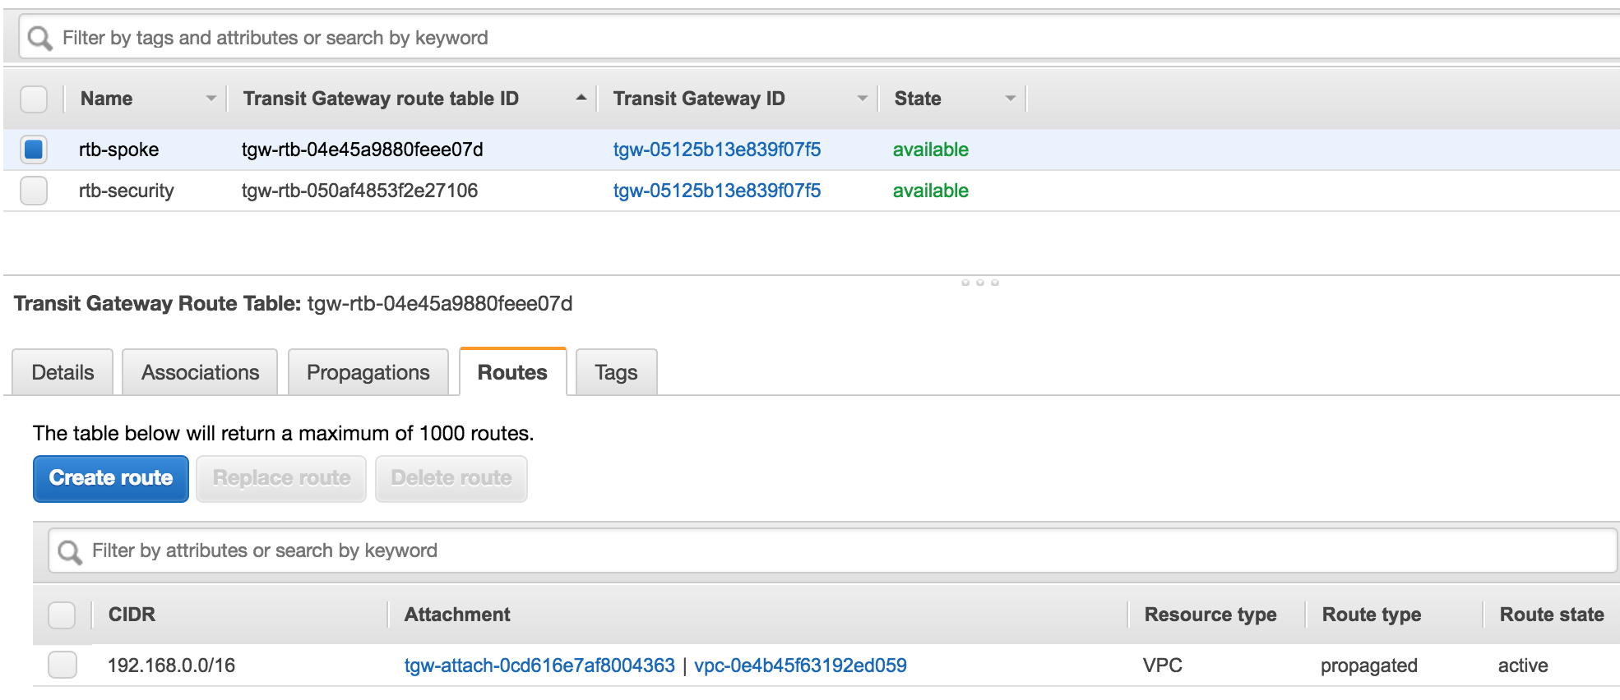
    3. In this use case, all Outbound traffic will flow through the firewalls. A manual route is necessary to handle that traffic.
    4. Select the Create Route button. Specify 0.0.0.0/0 for the CIDR and the Security Attachment. 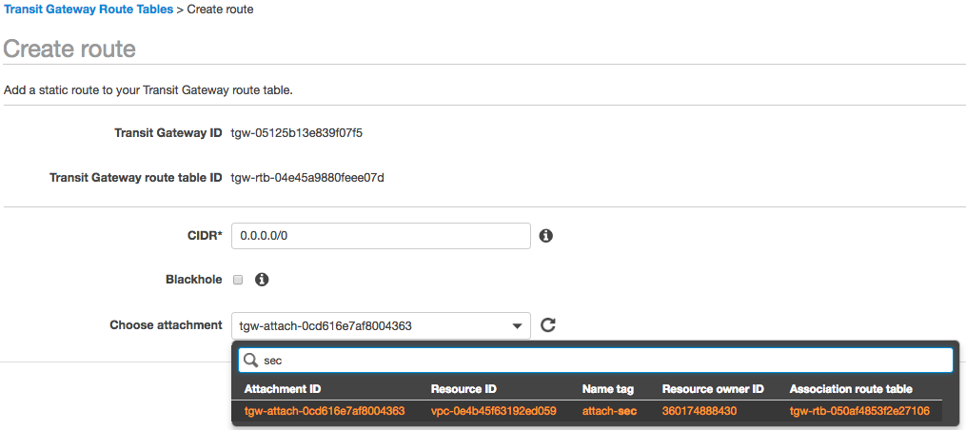
    5. Select the Create Button and verify the newly created route. 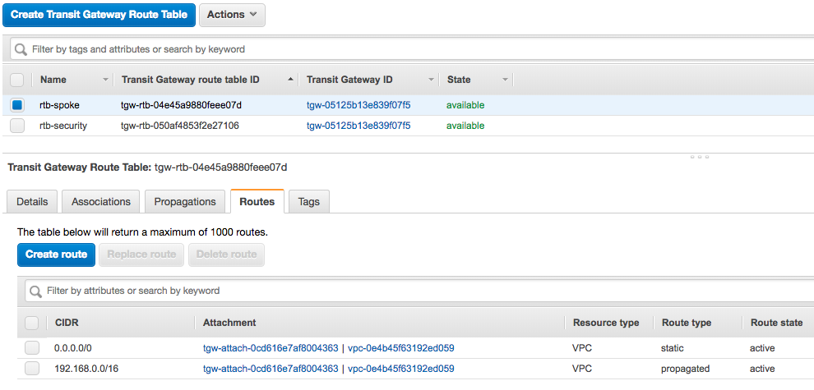
    6. Repeat Process for the Security Route table for both Spoke VPCs. 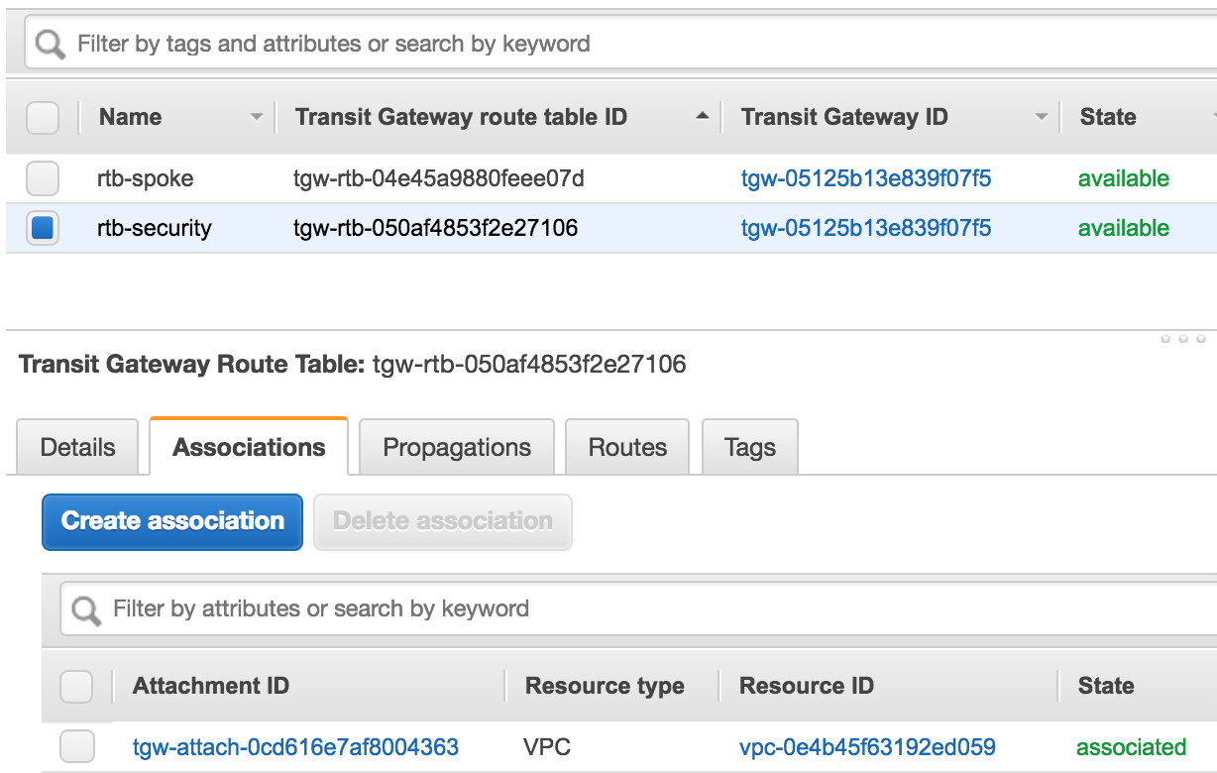

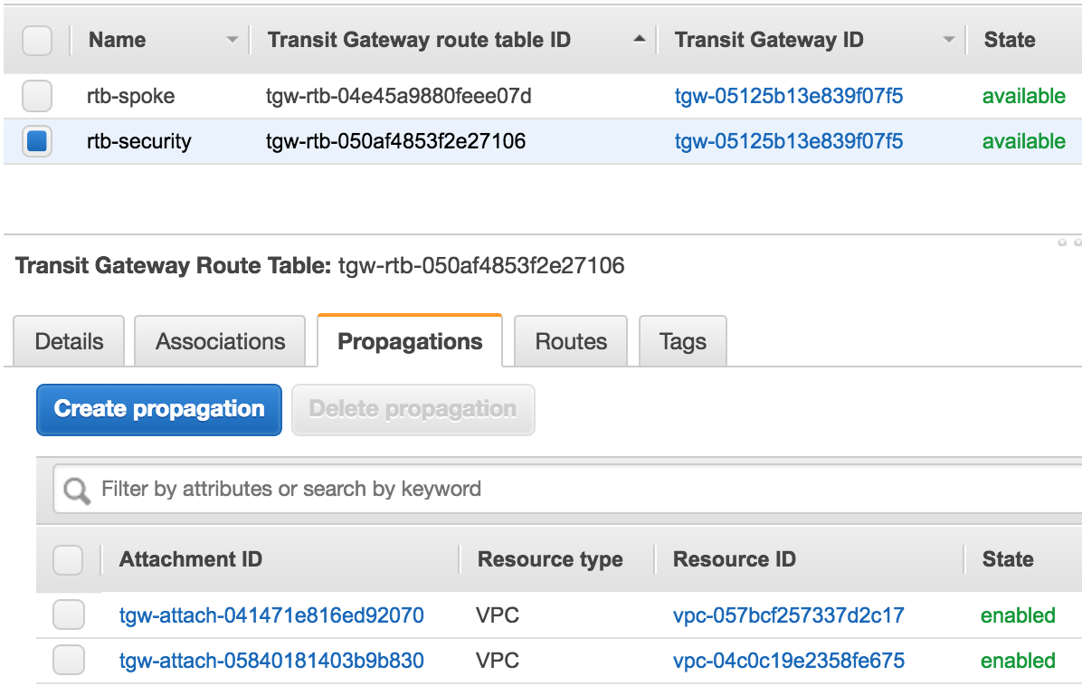

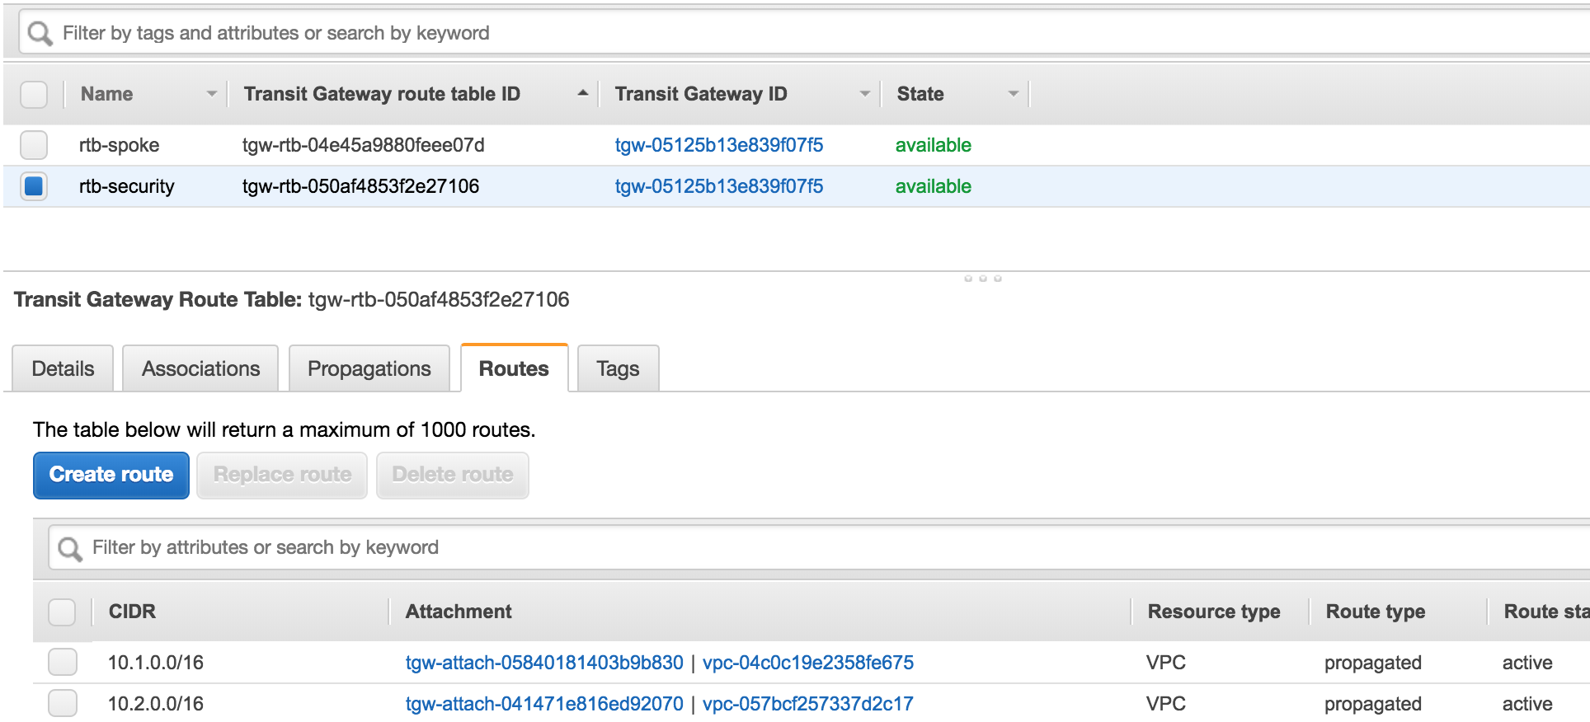

* + 1. Both Route tables should now have their corresponding Attachments and Route to the opposing VPC attachments.

# VPC Route Tables

## Overview

With the attachments now created in the VPC, the guide will step through the necessary route table creations in each of the VPCs.

* 1. Security VPC Internet Gateway
     1. In the AWS console, open the VPC Service.
     2. Select Internet Gateways in the left-hand menu and select the Create internet gateway button.
     3. Specify a new for the IGW. 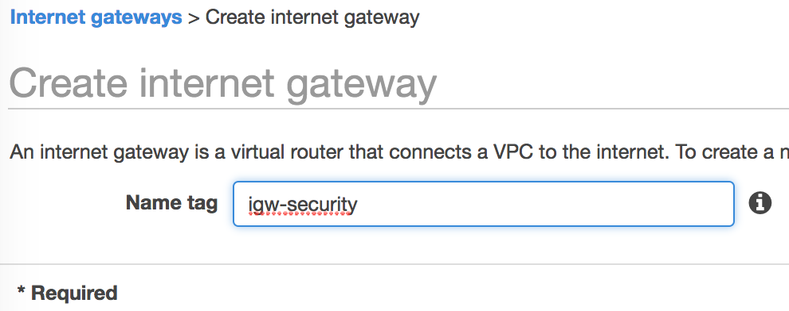
     4. Select the Create and button and close on the following screen.
     5. Highlight the newly create Internet Gateway, select the Actions dropdown and Attach to VPC. 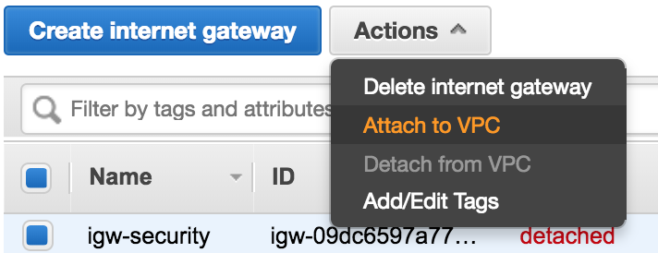
     6. Select the Security VPC from the dropdown and hit the Attach button. 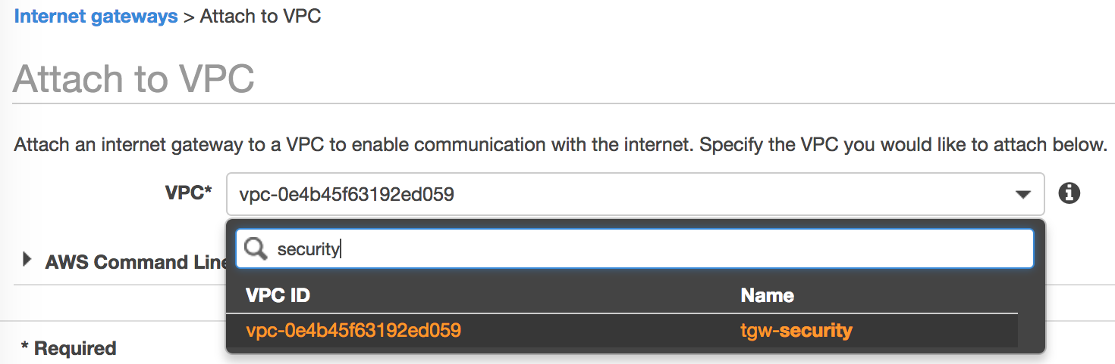
  2. Spoke Route Tables
     1. In the AWS console, open the VPC Service.
     2. Select Route Tables in the left-hand menu and select the Create route table button.
     3. Provide a name and Select Spoke 1. 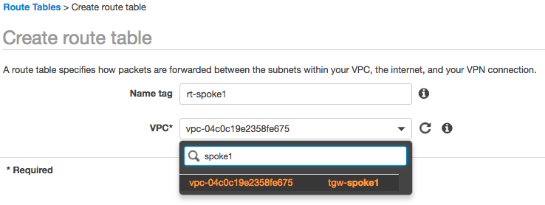
     4. Select the Create button and close on the following screen.
     5. Repeat the process for Spoke 2. 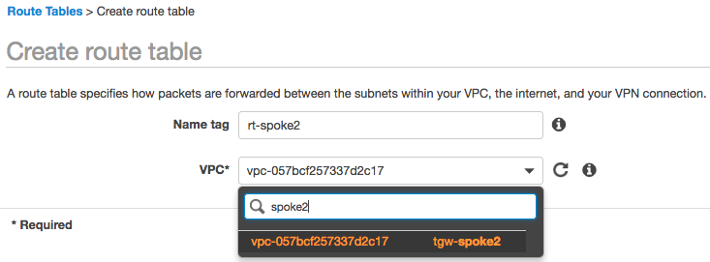
     6. Select rt-spoke1 and select the Route tab in the bottom pane. 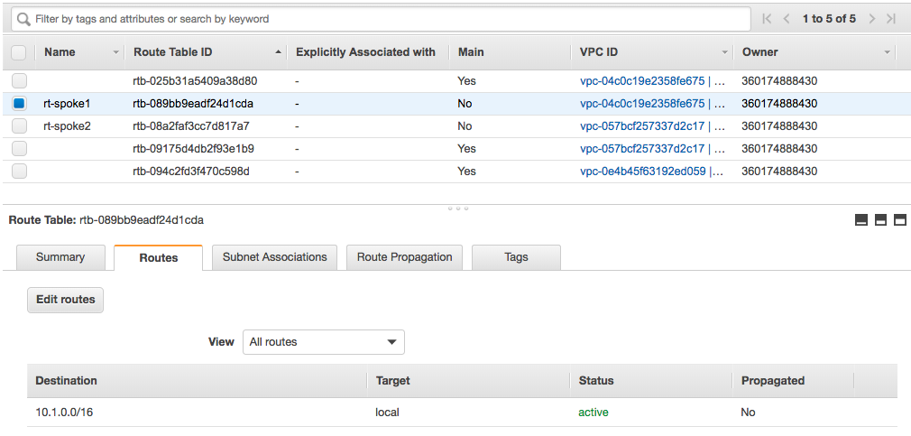
     7. Select the Edit route button and Add Route on the following screen.
     8. Specify 0.0.0.0/0 as the Destination and the TGW Attachment as the Target. 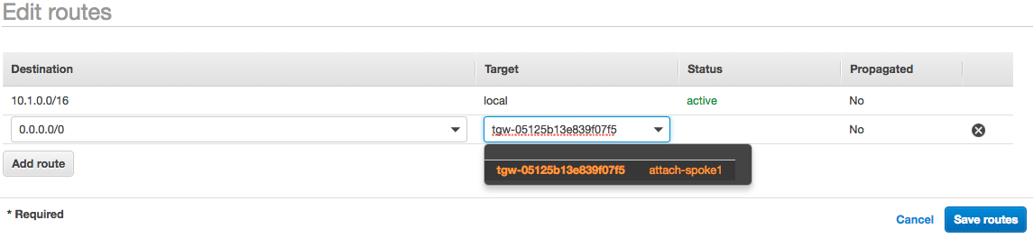
     9. Select Save Routes and Close on the following screen.
     10. Select Subnet Associations from the bottom pane and the Edit subnet associations button. 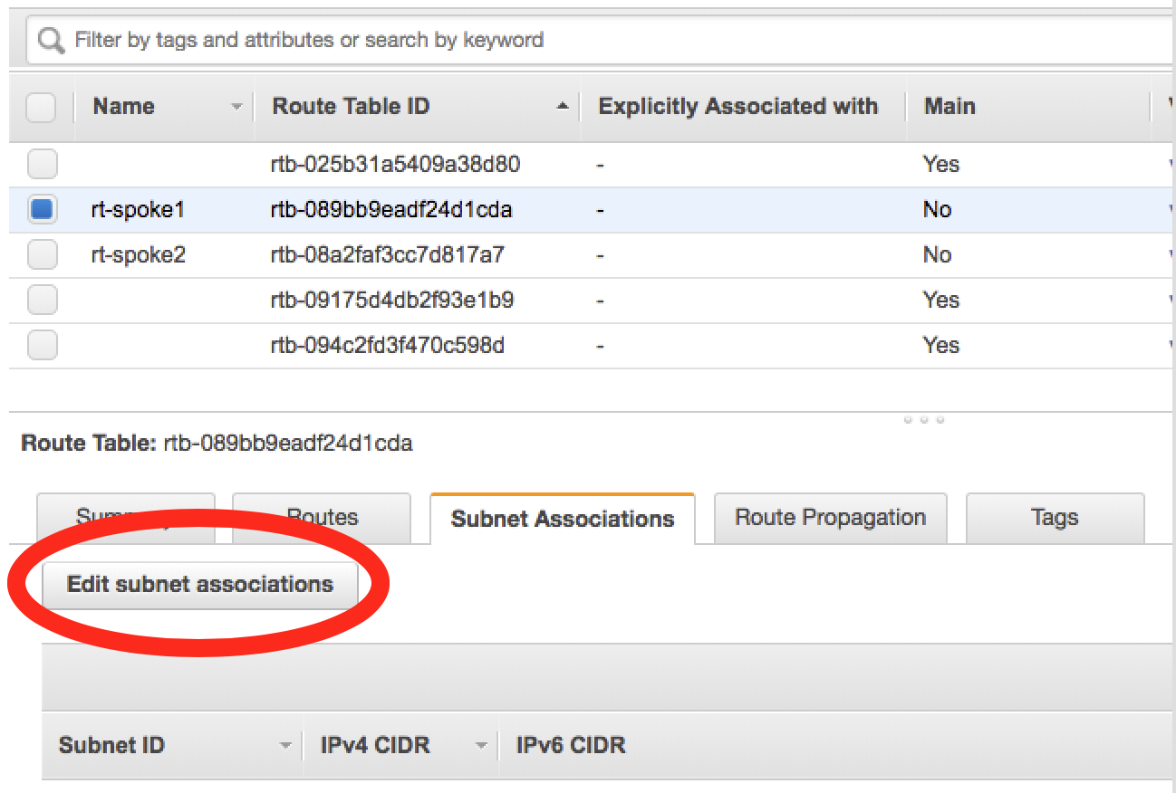
     11. Select the Spoke subnet and Save. 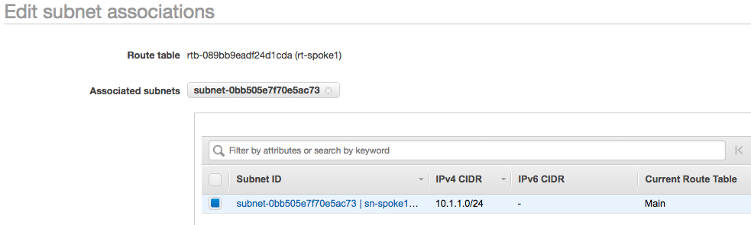
     12. Repeat the Process for Route Table of Spoke 2.
  3. Security VPC Route Tables
     1. In the AWS console, open the VPC Service.
     2. Select Route Tables in the left-hand menu and select the Create route table button.
     3. Specify an Outbound Name as this will be the Internet facing route table and select the Security VPC.

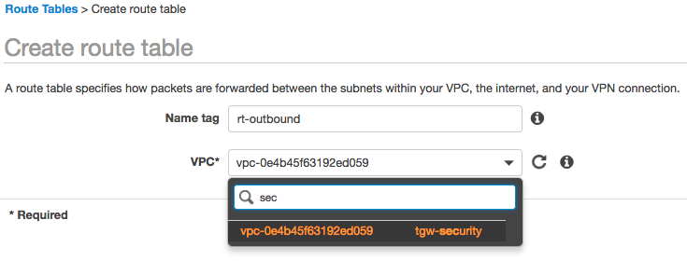

* + 1. Select the Create button and Close on the following screen.
    2. Highlight the newly created route table, select the Route tab in the bottom pane. 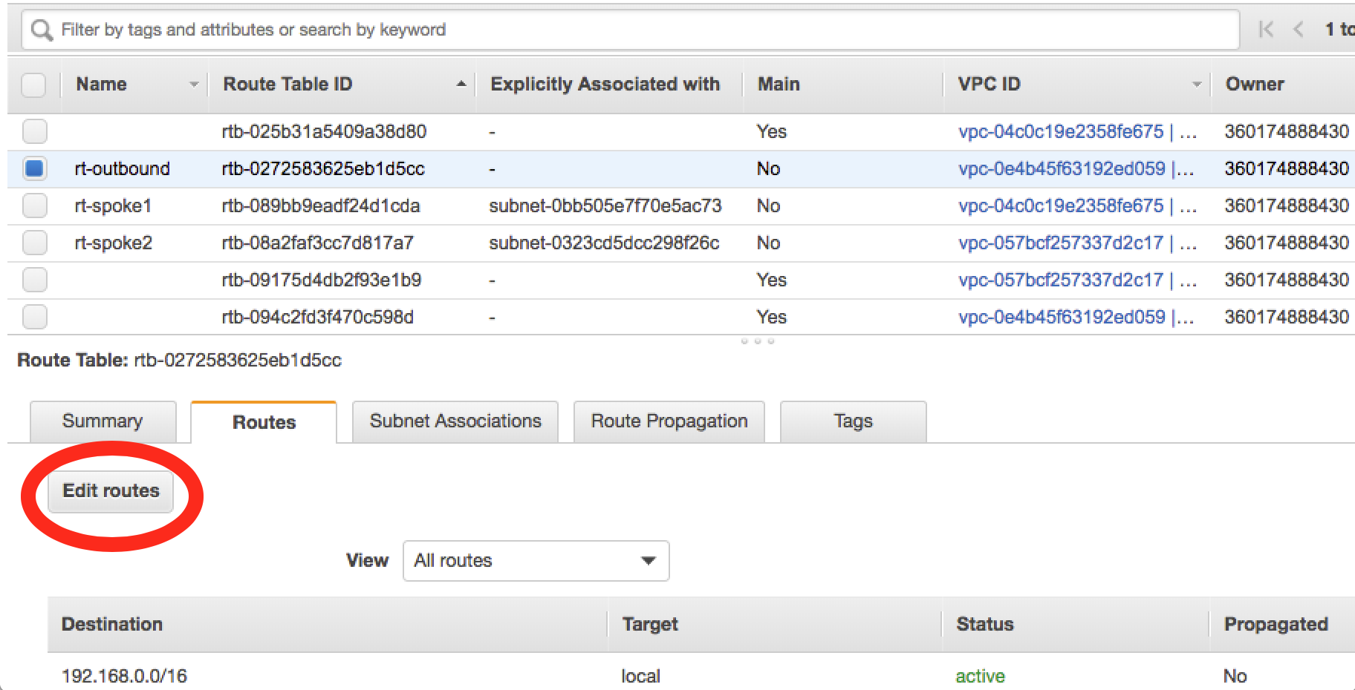
    3. Specify 0.0.0.0/0 as the destination and the previously create IGW as the Target. 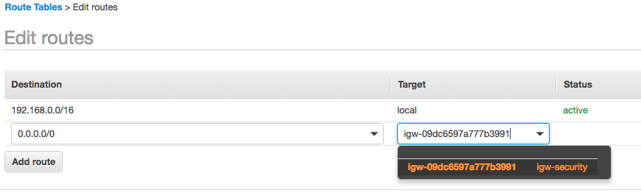
    4. Select the Save button and close on the following screen.
    5. Highlight the Outbound Route table, select Subnet Associations in the bottom pane and select Edit subnet Associations.

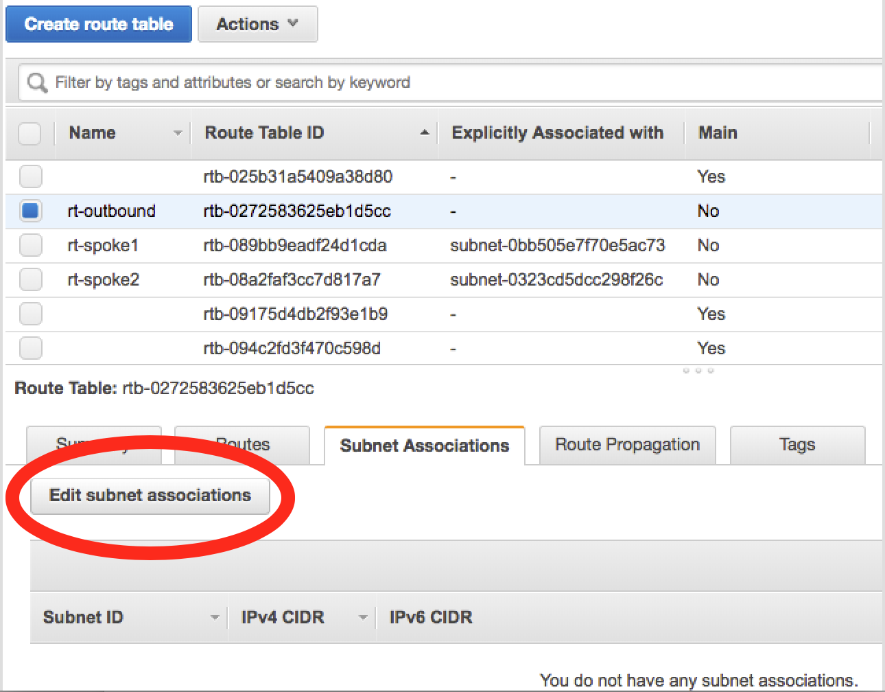

* + 1. Select the Management and Untrust subnets and hit the Save button. 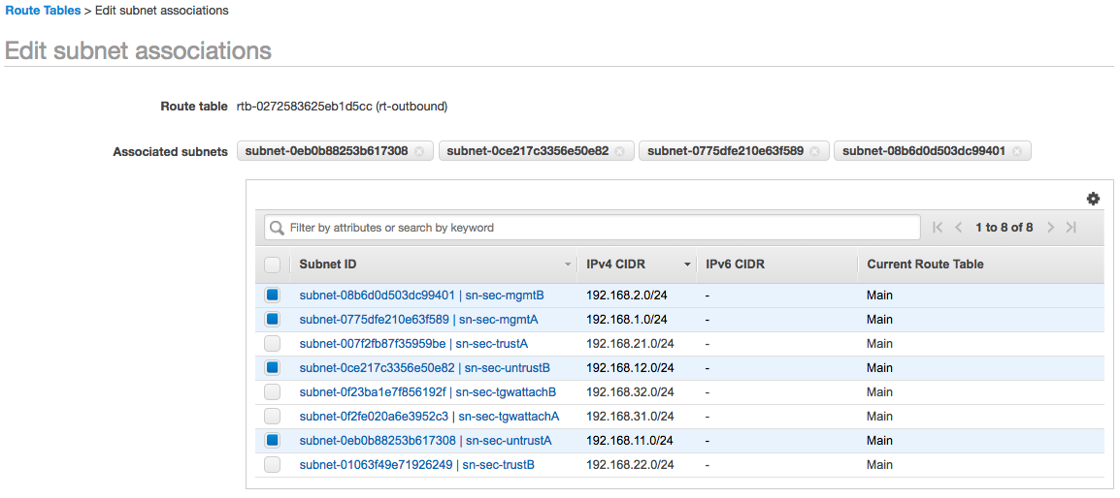
    2. Select the Create route table button. The route targeting the TGW will now be created.
    3. Specify a name and select the Security VPC. 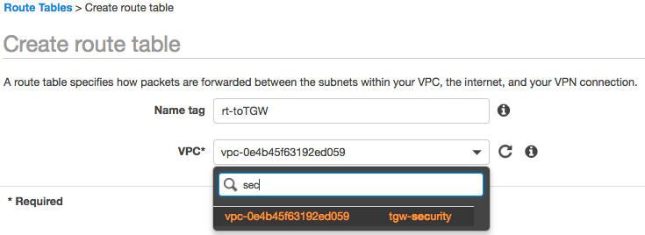
    4. Select the Create button and Close on the following screen.
    5. Highlight the route table for the TGW, Select Routes in the bottom pane and select the Edit routes button.

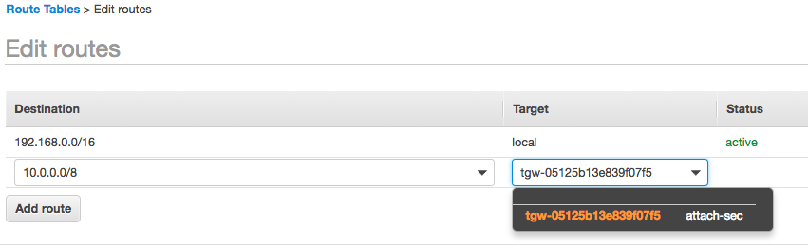

* + 1. Select the Save routes button and Close on the following screen.
    2. Highlight the route table for the TGW, Select Subnet Associations in the bottom pane and select the Edit subnet associations button.
    3. Select the Trust subnets. 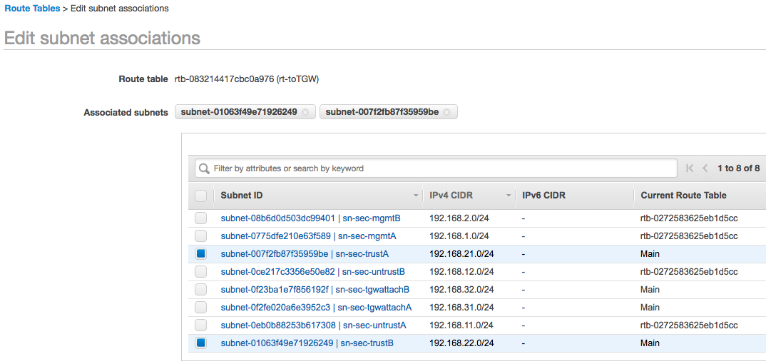
    4. Select the Save Button.

# Firewall Instances

## Overview

The reader will deploy 2 firewalls. One in each Availability Zone. The firewalls will contain 3 interfaces. Management, Trust and Untrust.

* While the guide does not implement a load balancer for an inbound use case, the guide will perform and interface swap during the build to facilitate inbound if desired. Refer to the follow article for more information. [Management Interface Mapping](https://docs.paloaltonetworks.com/vm-series/7-1/vm-series-deployment/set-up-the-vm-series-firewall-in-aws/management-interface-mapping-for-use-with-amazon-elb.html)
* This guide will utilize 4 EIPS. The reader may choose to Utilize a Jumpbox to conserve EIPS in lieu of granting EIPs to the Management interfaces. That is outside the scope of this guide.
  1. Firewall Creation
     1. In the AWS console, open the EC2 Service.
     2. Select Instances in the left-hand menu and select the Launch Instance button.
     3. Select AWS Marketplace in the left-menu and search for "Palo Alto Networks".
     4. We will select Bundle 2 from the results as this will be short test and it is desirable to have functioning licensing.
* Licensing is outside the scope of this guide. For more information please refer to the [Licensing Types](https://docs.paloaltonetworks.com/vm-series/8-1/vm-series-deployment/license-the-vm-series-firewall/license-typesvm-series-firewalls.html#idee8aaedc-0452-4b4c-a5fb-b5626ca4297c) page.

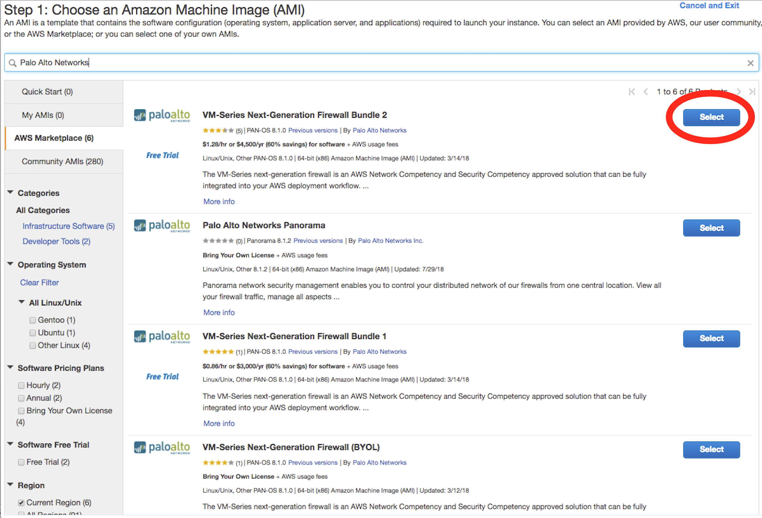

* + 1. Select Continue on the Marketplace/EULA page.
* If this is the first PayGo based deployment of the AWS account, the reader will be required to accept the EULA before proceeding.
  + 1. If this is not a capacity-based testing environment, the default size for the region will be sufficient. This guide was built in US-West-2, a m4-xlarge is chosen. Select the Configure Instance Details button.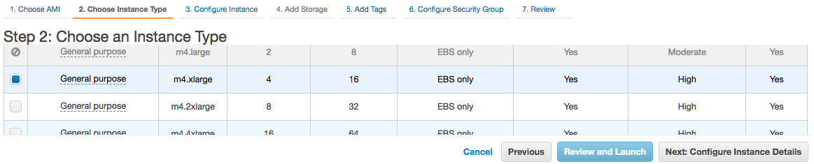
    2. On the Configure Instance Details screen, perform the following configuration outside of the defaults.
       1. Number of Instances: 1
       2. Network: Security VPC
       3. Subnet: UntrustA NOTE: Interface Swap will be performed.
       4. Auto-assign Public IP: Disable
       5. Network Interfaces. Add Device. Specify MGMTA
       6. Expand Advanced Details and paste the following into the User Date field As Text
          1. mgmt-interface-swap=enable

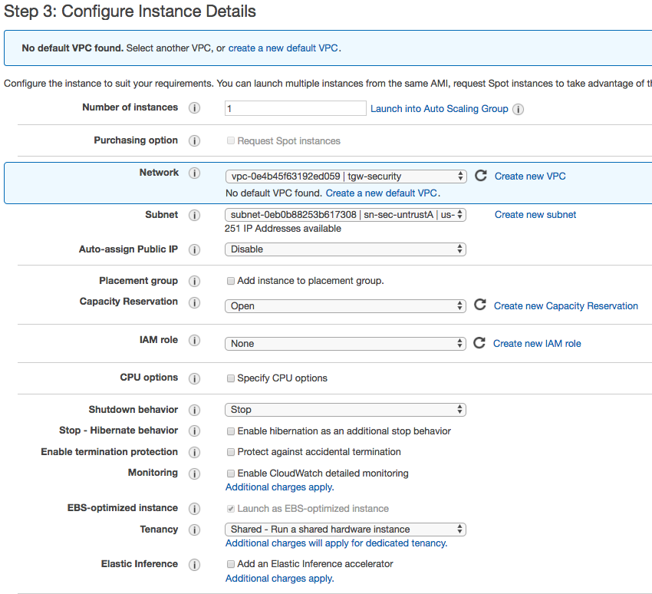

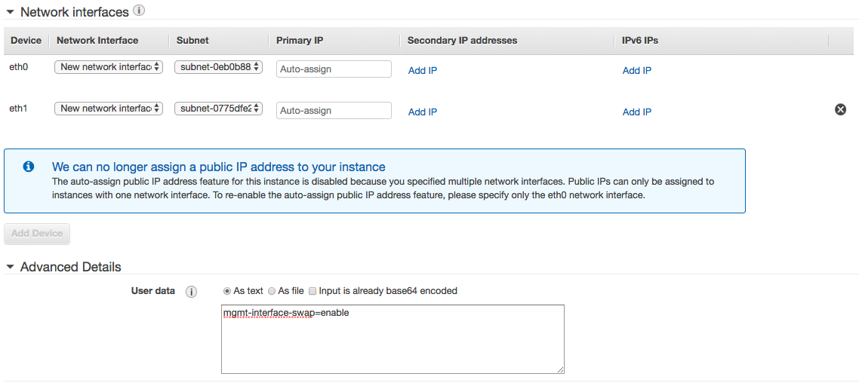

* + 1. Select the Add Storage Button, no changes are necessary.
    2. Select the Add Tags Button. The Reader could optionally add tags here such a Name. 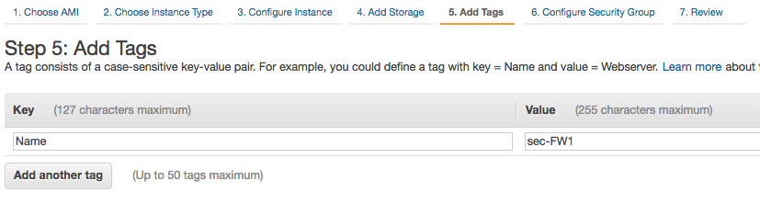
    3. Select the Configure Security Groups Button. Modify the Create a New Security Group Parameters to Allow All Traffic from 0.0.0.0/0 as this will be the Untrust SG. The guide will walk the reader through Management Lock down subsequently. 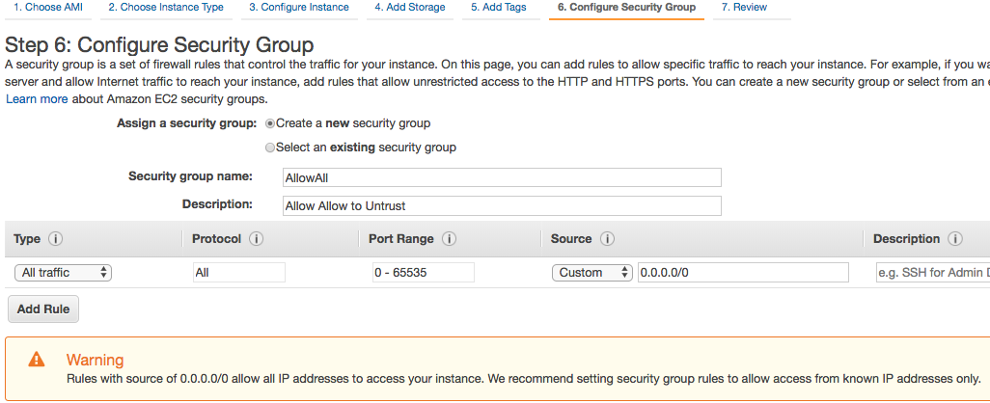
    4. Select Review and Launch.
    5. Review the parameters and select the Launch button.
    6. Either Create a new key pair or Select an existing key pair as necessary. Select Launch Instances.
    7. Repeat the process deploying a Second Firewall into the corresponding Subnets in the second Availability Zone.
    8. While the firewalls are deploying. Select Security Groups from the left-hand menu. Select Create Security Group button.
    9. Add 2 rules with a Source of My IP for HTTPS and SSH. 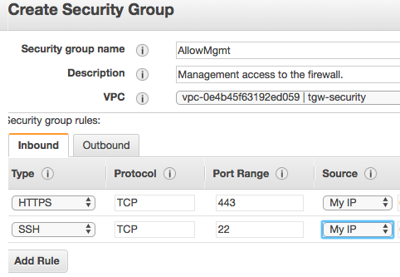
    10. Select Instances from the left-hand menu and highlight the Firewall.
    11. Select Description in Bottom Pane, ETH1 and then select the link to the ENI. 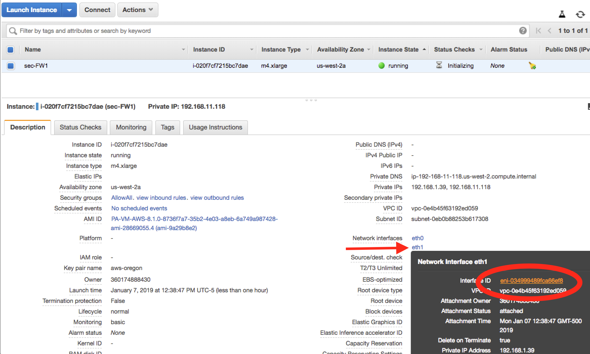
    12. This will navigate to the Network Interfaces menu. Select Actions in the Dropdown and Change Security groups.
    13. Select the newly created AllowMgmt security group and save. 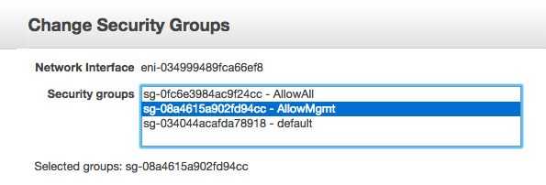
    14. Return to the Instance and select the link for ETH0 which is the Untrust interface.
    15. In the Actions Dropdown, select Change Source/Dest Check.
    16. Disable Source/Dest. Check and save.

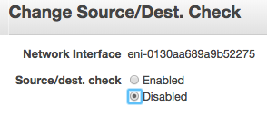

* + 1. Repeat the Management Group assignment and source/dest check on the second firewall.
  1. Trust Interface creation
     1. In the AWS console, open the EC2 Service.
     2. Select Network Interfaces in the left-hand menu and select the Create Network Interface button.
     3. Provide a description of the interface, specify the Trust Subnet in Availability Zone A and specify the Allow All Security Group. 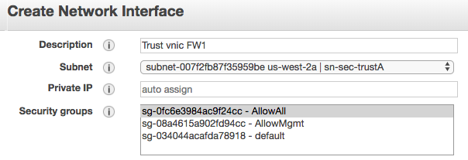
     4. Select Yes, Create.
     5. Highlight the newly created Interface, hit the Actions Dropdown and Select Change Source/Dest. Check. Set check to Disabled and Save.

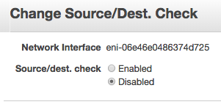

* + 1. With the interface still highlighted, select the Actions dropdown and Attach.
    2. Select FW1 from the Dropdown and Attach.

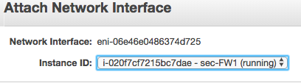

* + 1. Repeat the Network Interface Process for the second firewall.
  1. Elastic IP Addresses
     1. In the AWS console, open the EC2 Service.
     2. Select Elastic IPs in the left-hand menu and select the Allocate new address button.
     3. Accept the defaults and hit the Allocate button and Close in the following screen.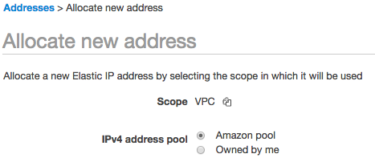
     4. Repeat this process 3 more times for a total of 4 EIPs.
     5. Select Instances in the left-hand menu and highlight Firewall1.
     6. Select ETH0 in the Description pane and open the ENI link.
     7. Select Actions in the Dropdown and Select Associate Address.
     8. Select one of previously allocated addresses in the Address dropdown and hit the Associate Address button. 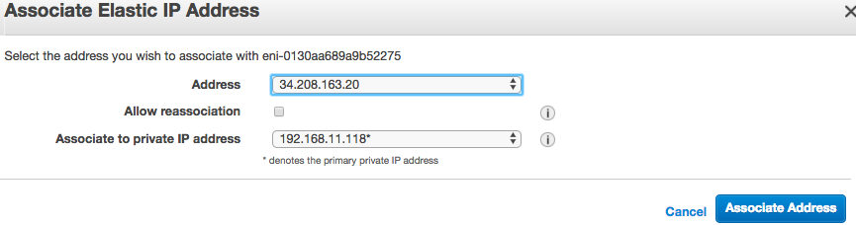
     9. Repeat this process on Firewall 1 ETH1.
     10. Repeat this process on Firewall 2 ETH0.
     11. Repeat this process on Firewall 2 ETH1.

This Procedure will result in both firewalls having EIPs associated with their first two interfaces.

# Firewall Configuration

## Overview

The reader will now access the firewalls to perform initial configuration and apply policies to allow communications. The firewalls will first be configured with a secure password via ssh. Once completed, the remaining configuration will occur via browser.

* 1. Admin Password
     1. In the AWS console, open the EC2 Service.
     2. Select Instances in the left-hand menu and select FW1.
     3. Select ETH1 in the Description tab of the bottom pane and copy the Public IP address.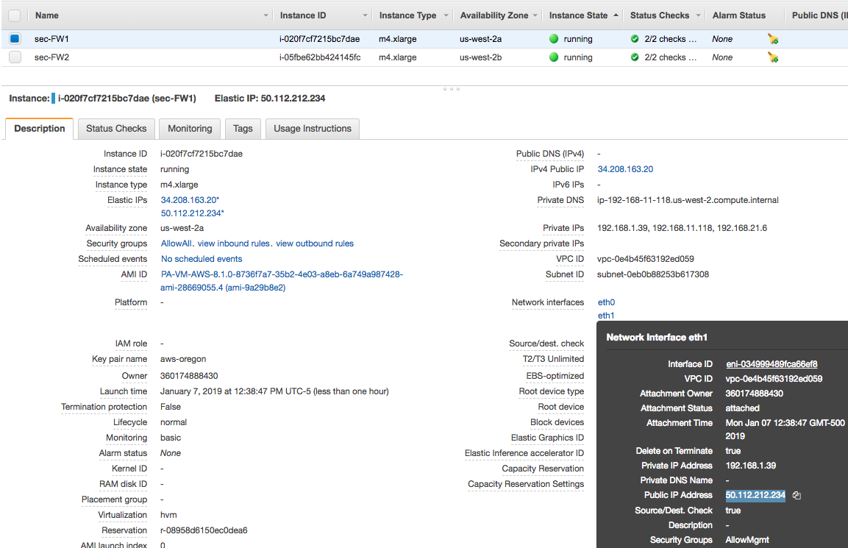
     4. In SSH client of the readers choosing. Connect to the Public IP address specifying the Private Key designated during instance creation and admin as the account. E.g.
        1. ~/.ssh$ ssh -i aws-oregon.pem [admin@50.112.212.234](mailto:admin@50.112.212.234)
     5. Type 'configure' at the Firewall Command prompt.
     6. To specific the password, use the following command.
        1. set mgt-config users admin password
     7. Specify and confirm a security password.
     8. Type 'commit' once the firewall has returned to the command prompt.
     9. Type 'exit' to leave configuration mode, type 'exit' again to end the SSH session.\
     10. Repeat this process on FW2.
  2. Firewall Configuration
     1. Open a New Browser tab and HTTPS to the same IPs addresses used to set the password.
     2. Accept the Self Signed Certificate and login in with Username admin and the password previously configured.
     3. Close the Welcome Message to access the Dashboard.
     4. Access the Network Tab, Zones on the left-hand menu and Select Add at the bottom of the Window.
     5. Create a Zoned for Untrust and set the Type to Layer3. 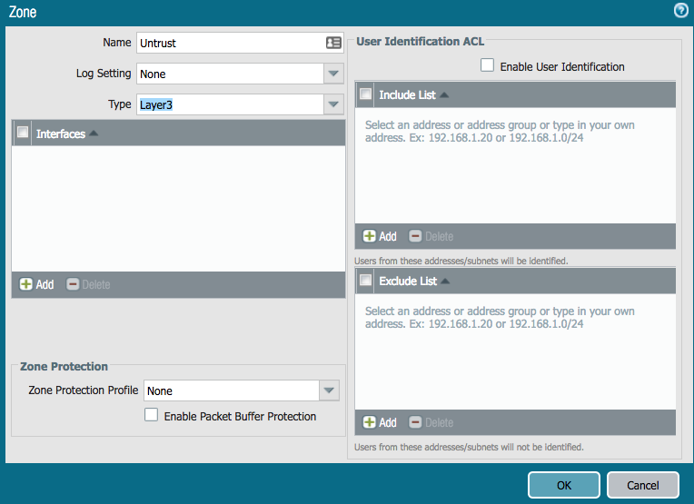
     6. Repeat the process for the Trust Zone. 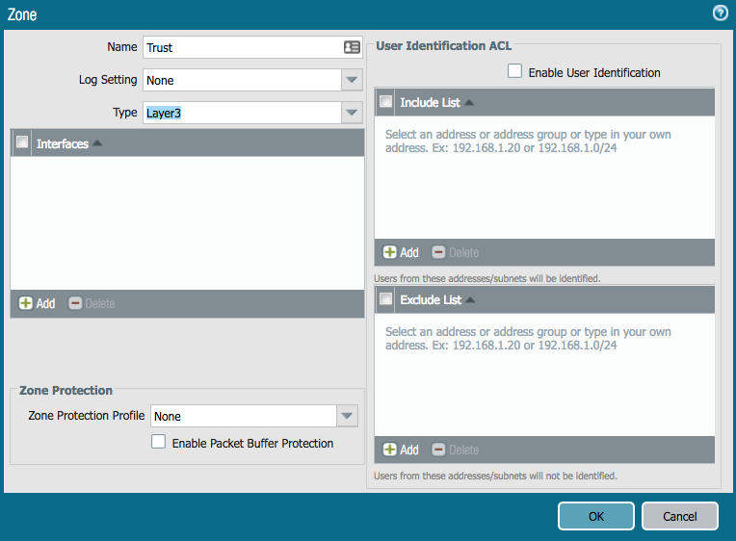
     7. Access the Network Tab, Interfaces on the left-hand menu and Select Ethernet 1/1.
     8. Set Interface Type to Layer3 and Access the Config Tab. Set the Virtual Router to Default and the Security Zone to Untrust. 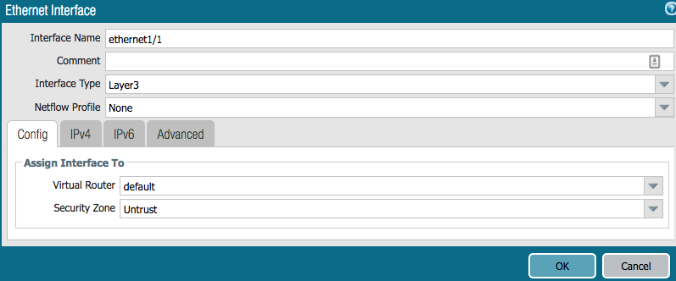
     9. Access the IPv4 Tab and set type to DHCP. 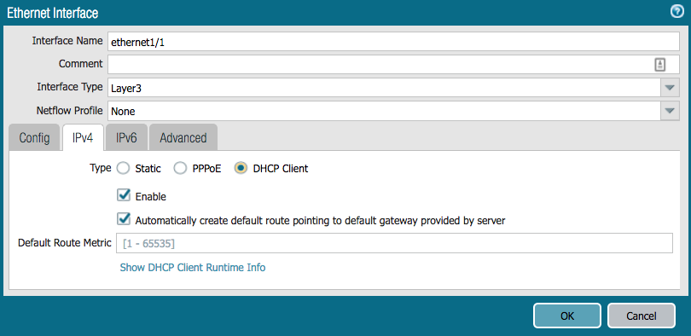
     10. Select OK to Close.
     11. Repeat the Process for Ethernet 1/2.
* Set the Security Zone to Trust
* Uncheck " Automatically create default route pointing to default gateway provided by server" box in the DHCP Settings.

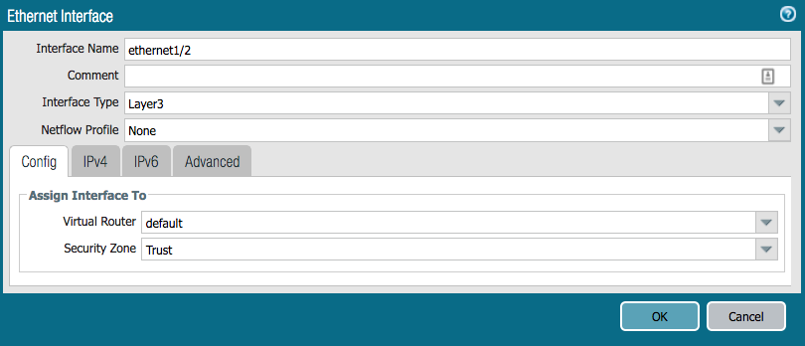 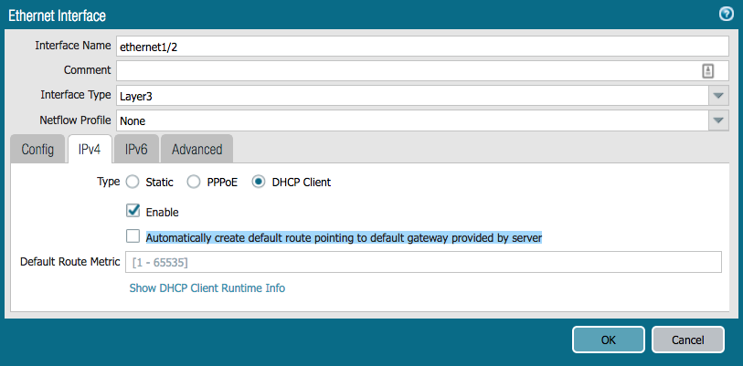

* + 1. Select Virtual Routers in the left-hand menu and open the 'default' VR.
    2. Select Static Routes in the left-hand menu and hit the add button.
       1. Name: SpokeRoute
       2. Destination: 10.0.0.0/8
       3. Interface: ethernet1/2
       4. Next Hop: 192.168.2x.1 (Specify the .1 address of the Trust subnet.) 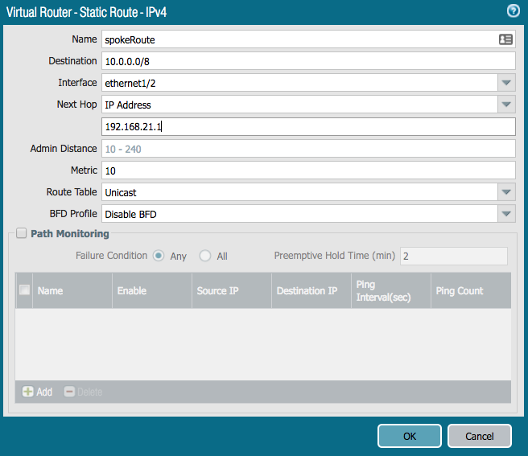
    3. Select OK twice to exit.
    4. Select the Policies Tab, Security in the left-hand menu and Add in the bottom of the window.
    5. General Tab, Name=AllowAll 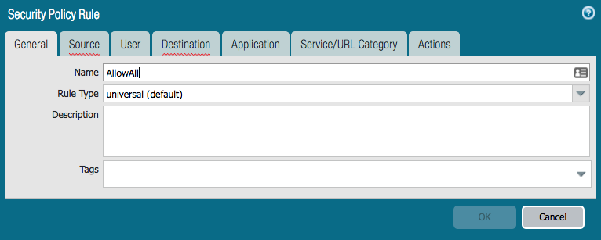
    6. Source Tab, Source Zone = Any 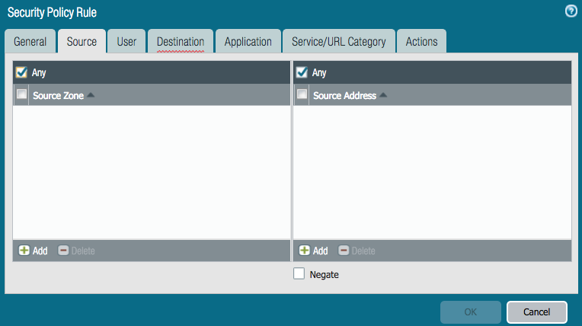
    7. Destination Tab, Destination Zone = Any 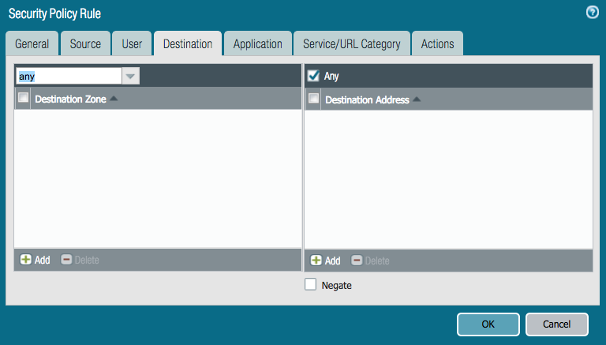
    8. Service/URL Category. Service=any 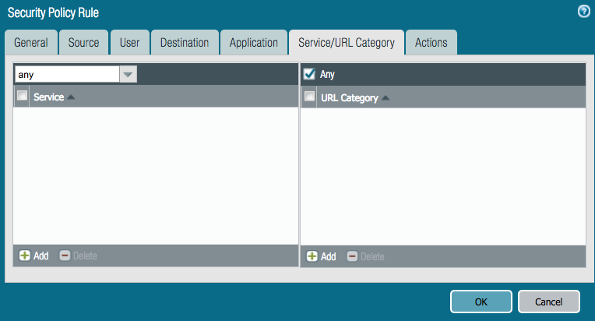
    9. Select OK to accept all other defaults. 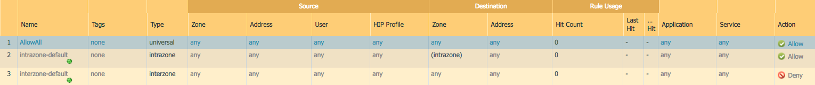
    10. Select NAT in the left-hand menu and Add button at the bottom of the window.
    11. General Tab, Name = OutboundNAT. 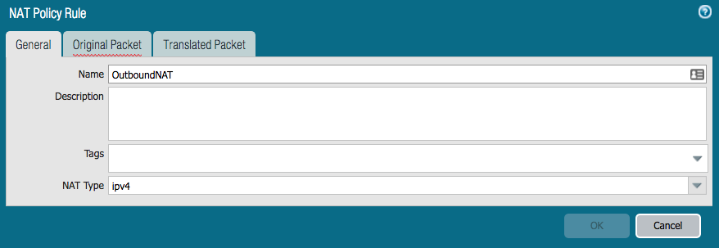
    12. Original Packet Tab, Source Zone = Trust, Destination Zone = Untrust. 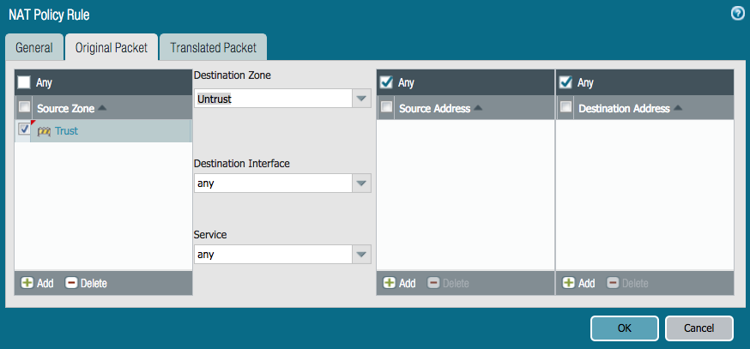
    13. Translated Packet Tab. Source Address Translation.
        1. Translation Type: Dynamic IP and Port
        2. Address Type: Interface Address
        3. Interface: ethernet1/1 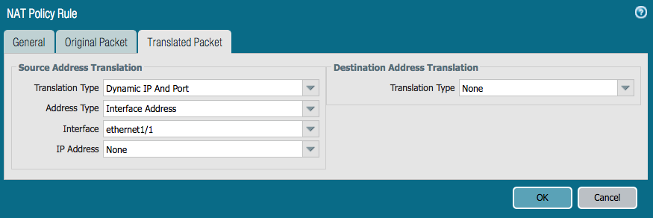
    14. Select OK.
    15. Select Commit and Hit the Commit button.
    16. Repeat the Process for Firewall 2.

# Route Table Updates

## Overview

Now that the firewall ENIs have been created. The VPC Route Tables can be created to direct traffic arriving from the TGW Attachment to the firewalls. While there are different options for routing the East/West and Outbound traffic, this guide will utilize FW1 for East/West and FW2 for Outbound.

Only one firewall is used for East/West routing to eliminate the need to Source NAT.

* This guide does not cover firewall fault tolerance or scaling. Options for fault tolerance include [AWS HA](https://docs.paloaltonetworks.com/vm-series/8-0/vm-series-deployment/set-up-the-vm-series-firewall-on-aws/high-availability-for-vm-series-firewall-on-aws) or route update scripting to update the route table in the event of a failure.
* Scaling beyond the throughput of the firewall would involve segmenting spoke traffic toward specific firewalls and is outside the scope of this guide.
  1. Attachment Route Table
     1. In the AWS console, open the EC2 Service.
     2. Select Instances in the left-hand menu and select the Highlight FW1.
     3. Select ETH2 in the Description Tab and copy the Interface ID. 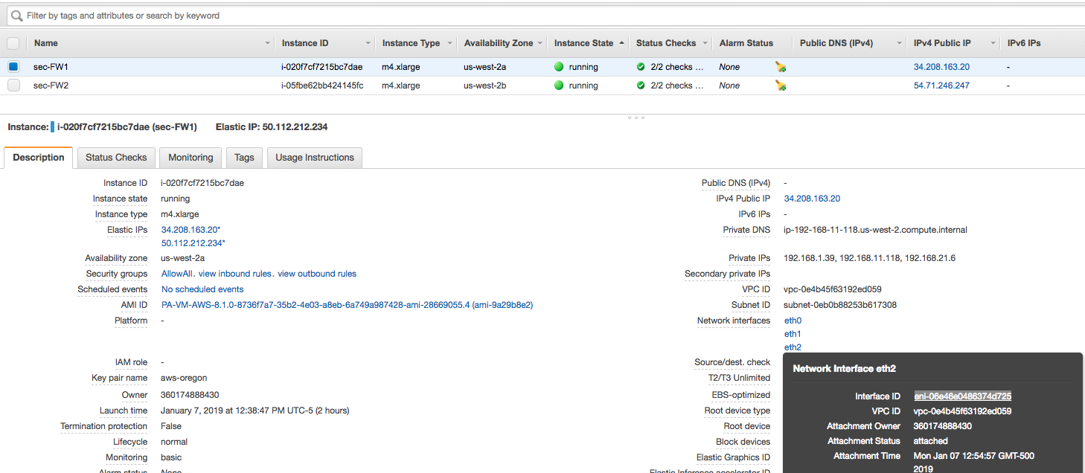
     4. Paste the contents into text editor.
     5. Repeat for FW2.
     6. In the AWS console, open the VPC Service.
     7. Select Route Tables in the left-hand menu and select the Create Route table button.
     8. Provide a Name and select the Security VPC. 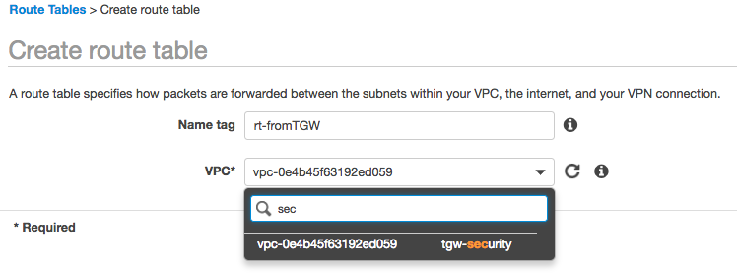
     9. Select the Create button and Close on the following screen.
     10. Highlight the newly created Route Table, select the Routes Tab and hit the Edit Routes button.
     11. Add two routes utilizing the previously copied ENI IDs.
         1. 10.0.0.0/8 -> ENI of ETH2 FW1
         2. 0.0.0.0/0 -> ENI of ETH2 FW2
     12. Save and Close.
     13. Select the Subnet Associations Tab in the bottom pane and hit the Edit Subnet Associations button.
     14. Select the TGW Attachment Subnets and hit Save. 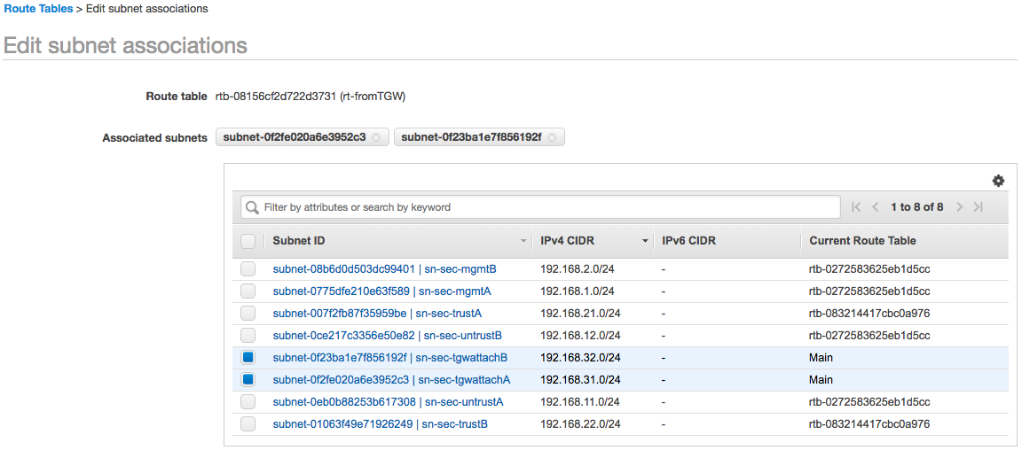

# Client Systems

## Overview

This guide steps the reader through deploying to test systems, one in each spoke to perform flow tests and review the traffic in the Firewall Monitor.

* This guide will use Ubuntu running on free tier instances. The reader may choose to use other systems that is more suitable.
  1. Client System
     1. In the AWS console, open the EC2 Service.
     2. Select Instances in the left-hand menu and select the Launch Instance button.
     3. Search for Ubuntu and select Ubuntu Server 18.04 LTS.
     4. Leave the Free Tier Eligible instance size highlighted and select Configure Instance Details.
     5. In the Network Parameter, specific the Spoke1 VPC and select Add Storage.
     6. Accept the defaults and select Add Tags. Tags are optional, the reader may choose to specific a Name tag.
     7. Select the Configure Security Group button.
     8. The reader will connect to the system with SSH through the firewall. Therefore, a security is necessary to allow SSH. 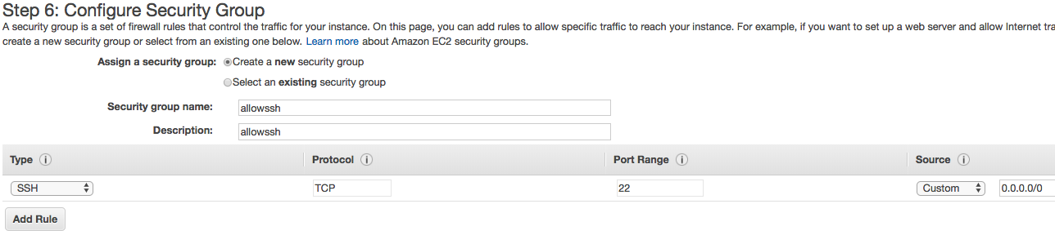
     9. Select the Review and Launch button.
     10. Review the Parameters and select the Launch button.
     11. Specify the correct Key Pair in the pop-up and Launch the Instance.
  2. Web Server
     1. In the AWS console, open the EC2 Service.
     2. Select Instances in the left-hand menu and select the Launch Instance button.
     3. Search for Ubuntu and select Ubuntu Server 18.04 LTS.
     4. Leave the Free Tier Eligible instance size highlighted and select Configure Instance Details.
     5. In the Network Parameter, specific the Spoke2 VPC.
     6. Expand the Advanced Details Section and paste the following As Text.
* Be careful of word wrap introduced by the document editor specifically on the wget command

#!/bin/bash

sudo apt-get update &&

sudo apt-get install -y apache2 php7.0 &&

sudo apt-get install -y libapache2-mod-php7. &&

sudo rm -f /var/www/html/index.html &&

sudo wget -O /var/www/html/index.php <https://raw.githubusercontent.com/jasonmeurer/showheaders/master/showheaders.php> &&

sudo echo "done"

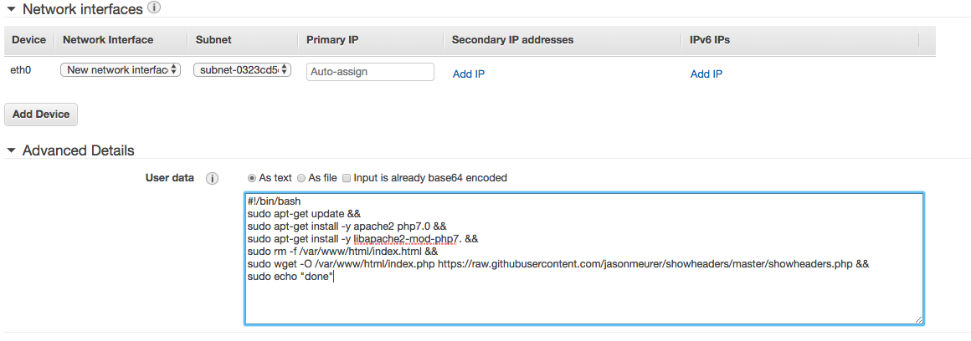

* + 1. Add Storage.
    2. Accept the defaults and select Add Tags. Tags are optional, the reader may choose to specific a Name tag.
    3. Select the Configure Security Group button.
    4. The reader will connect to the system with SSH through the firewall. Additionally, the website is configured on port 80. Therefore, a security is necessary to allow SSH and HTTP. 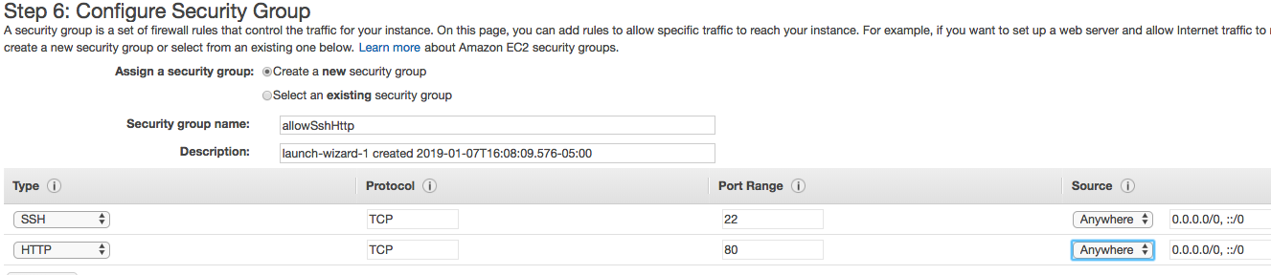
    5. Select the Review and Launch button.
    6. Review the Parameters and select the Launch button.
    7. Specify the correct Key Pair in the pop-up and Launch the Instance.

# Firewall Configuration - Inbound

## Overview

This test systems to not currently allow for inbound access from the Internet. The reader will now configure an inbound NAT rule through FW1 to allow access to the test client to perform tests.

The NAT policy will perform Port translation from port 222 externally to port 22 on the instance. The reader could create a second NAT policy utilizing a second external port to gain access to the web server.

* 1. Nat Policy Configuration
     1. In the AWS console, open the EC2 Service.
     2. Select Instances in the left-hand menu and highlight client system. Copy the IP address.
     3. Repeat the process for Eth0 of FW1.
     4. Switch to the browser connected to FW1.
     5. Open the Objects Tab, Select Services from the left-hand menu and hit the Add button.
     6. Specify a relevant name and set the destination port to 222. 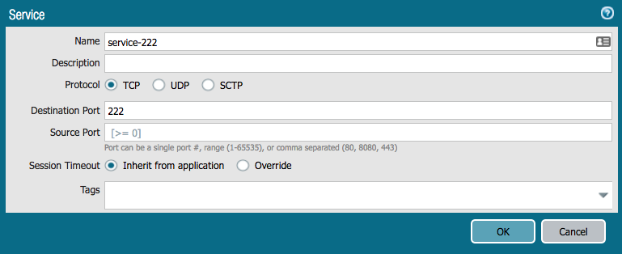
     7. Open the Policies tab, select NAT in the left-hand menu and hit the Add button at the bottom.
     8. Provide a Rule name such as inboundMgmt.
     9. Move to the Original Packet tab. Set both the Source and Destination Zones to Untrust.
     10. Specify the firewall IP of ETH0 as the Destination Address.
     11. Specify the Service as the previously created 222 port. 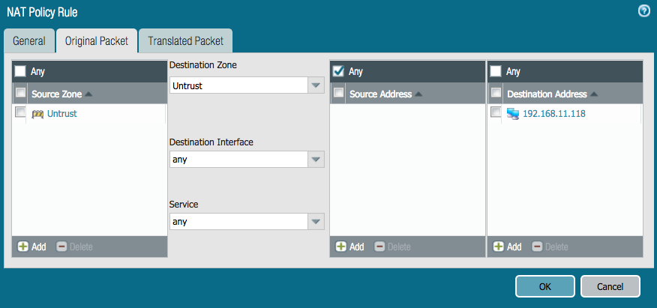
     12. Move to the Translated Packet Tab.
     13. Source Address Translation
         1. Translation Type: Dynamic IP and Port
         2. Address Type: Interface Address
         3. Interface: ethernet1/2
     14. Destination Address Translation
         1. Translation Type: Static IP
         2. Translated Address: IP of the client system
         3. Translated Port: 22 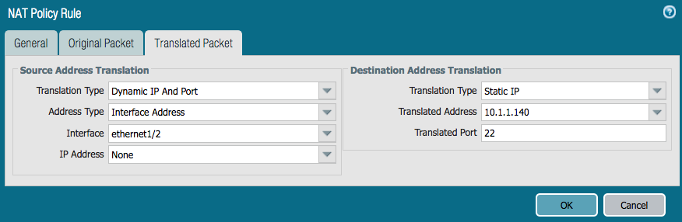
     15. Commit the Policy.

# Validation

## Overview

The reader will now access the client system via SSH to perform both East/West and Outbound testing.

* 1. Access the Client System
     1. In the AWS console, open the EC2 Service.
     2. Select Instances in the left-hand menu and highlight FW1 system. Copy the Public IP of ETH0.
     3. From a terminal window, ssh to the public IP on port 222 utilizing a Username of Ubuntu and the designated key.
        1. ~/.ssh$ ssh -p 222 -i aws-oregon.pem [ubuntu@34.208.163.20](mailto:ubuntu@34.208.163.20)
     4. Once access to the cli has been gained, the reader can test access to Internet and to the web server IP address utilizing the curl command.
     5. FW2 - Outbound Traffic 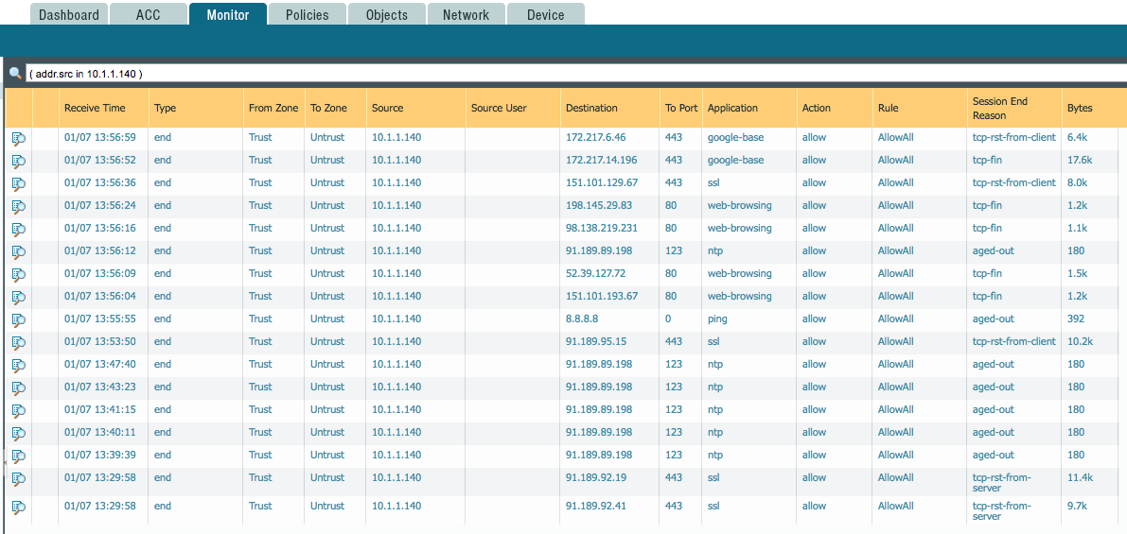
     6. FW1 - East/West Traffic. 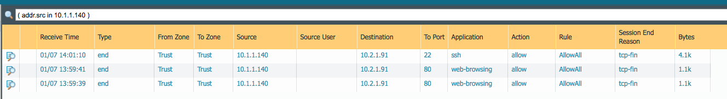

## 

# For More Information

AWS Transit Gateway

<https://aws.amazon.com/transit-gateway/>

Palo Alto Network Cloud Resources

<https://live.paloaltonetworks.com/t5/Cloud-Integration/ct-p/Cloud_Templates>